

Machine Learning for Thermal Soaring

Travis Crumley, David Egolf, Garrett Wilson

6/6/2016

Advisor:

Professor Ralph Stirling

Abstract

Our goal was to increase glider flight time by writing software for autonomously finding and using thermal updrafts. We split our work into three parts: basic implementation of an existing algorithm, exploration of thermal identification methods, and exploration of machine learning methods for more flexible decision making.

The basic implementation incorporated results from Edwards and Allen into a simple algorithm that could be easily tested and deployed. We successfully implemented this method in the Piccolo autopilot simulator.

In order to improve thermal identification, we examined both Bayesian parameter estimation and Gaussian process regression. We then tested and explored Gaussian process regression further, since it proved to be the most promising. Using Gaussian process regression, the glider successfully identifies and orbits thermals in simulation.

To increase the flexibility of decision-making, we investigated several machine learning methods for policy development: table-based Q-learning, neural fitted Q-learning, and dynamic programming with neural interpolation. Using dynamic programming with neural interpolation, the glider learns a plausible and adaptive policy that adjusts in response to thermal position and shape. We investigated these machine learning methods in a highly idealized environment, and current work is focused on transitioning to the more sophisticated CRRCSim simulator.

Table of Contents

Abstract 2

Table of Contents 3

Table of Figures 7

List of Tables 10

Acknowledgements 11

1 Introduction and Objectives 12

1.1 Introduction 12

1.2 Project Objectives and Requirements 12

2 Basic Implementation 13

2.1 Overview 13

2.2 Research 13

2.3 Finding Thermals 14

2.4 Simulation 14

2.5 Energy Estimation 15

2.6 Using the Data 17

2.7 The Centroid Method 17

2.8 Future Work 19

3 Thermal Identification 20

3.1 Overview 20

3.2 Introduction to Bayesian Probabilistic Methods 21

3.2.1 Review of Probability 21

3.2.2 Bayesian Inference 22

3.3 Bayesian Parameter Estimation 24

3.3.1 Square Thermals 24

3.3.2 Square Thermals with Partial Knowledge 25

3.3.3 Gaussian-shaped Thermals 26

3.4 Gaussian Process Regression 27

3.5 Comparison of Gaussian Process Regression and Bayesian Parameter Estimation 31

3.6 Gaussian Process Regression in Simulation 35

3.7 Bayesian Networks 37

3.7.1 Overview 37

3.7.2 Advantages of Bayesian Networks 38

3.7.3 Simple Example: Learning Conditional Probability Tables 39

3.7.4 Thermal Soaring: Learning the Network 41

3.8 Future Work 42

4 Creating a Policy 43

4.1 What is a Policy? 43

4.2 Using the Policy: States and Actions 44

4.3 How to Form a Policy? 45

4.4 Learning about Machine Learning 46

4.5 Choosing a Machine Learning Method 47

4.6 Implementing Machine Learning Methods: Overview 48

4.7 What is Dynamic Programming? 49

4.8 What is Temporal Difference Learning? 50

4.8.1 Interacting with the Environment 50

4.8.2 Learning from Interactions: Q Values 52

4.8.3 Discounting 53

4.8.4 Learning Rate 53

4.8.5 A Temporal Difference Learning Algorithm: SARSA Learning 54

4.8.6 Another Temporal Difference Learning Algorithm: Q-Learning 55

4.9 Initial Model Generation and Hill Climbing 56

4.10 Initial Classification and Regression 57

4.11 Understanding PyBrain’s Structure 61

4.12 Using PyBrain: Table-Based SARSA 62

4.13 Function Approximation with Neural Fitted Q 64

4.14 Dynamic Programming with Function Approximation 65

4.15 Adding Direction Information; Debugging with Linux 69

4.16 Transitioning to CRRCSim 70

4.17 Future Work 70

5 Autopilot and Hardware 71

5.1 The Plane 71

5.2 Switching from Piccolo to Pixhawk 71

5.3 Connecting with the Piccolo Simulator 72

5.3.1 Networking Motivation 72

5.3.2 Network Protocol 72

5.3.3 C++ Server 73

5.3.4 Python Client 74

5.4 Connecting with the Pixhawk Simulator 76

6 Conclusion 77

6.1 Ethical, Political, Sustainability, Manufacturability, Social, Health and Safety, Environmental, and Economic Concerns 77

6.2 Concluding Remarks 77

References 79

Appendix A – Autopilot and Simulator Setup 81

A.1 Pixhawk Simulator Setup Guide 81

A.2 Piccolo Setup Guide on Windows for Thermal Soaring 83

A.2.1 Installation 84

A.2.2 Running the Simulator with Thermals 84

A.2.3 Python Setup 85

A.3 Piccolo Simulator Set Up Guide (General Application) 86

A.3.1 Getting Started with Piccolo 86

A.3.2 Uses of Piccolo Software 88

A.3.3 Creating a simulation model 88

A.3.4 Reprogramming the Piccolo/Groundstation 89

A.3.5 Debugging 90

Table of Figures

Figure 1- General Loop From Edwards’s Paper 13

Figure 2- Latching Method from Edwards's Paper 14

Figure 3- Processing Cycle 17

Figure 4 - Centroid Method Flowchart from Allen's Paper 18

Figure 5. Thermal position probability distribution from Bayesian parameter estimation 21

Figure 6. Bayesian inference for temperature measurements 23

Figure 7. Bayesian inference for flipping a coin 23

Figure 8. Square Thermal with All Knowledge 24

Figure 9. Square Thermal Parameter Estimation with All Knowledge 24

Figure 10. Square Thermals Positions with Partial Knowledge 25

Figure 11. Square Thermal Parameter Estimation with Partial Knowledge 25

Figure 12. Gaussian-shaped Thermal Position 26

Figure 13. Gaussian-shaped Thermal Parameter Estimation 27

Figure 14. Changes in Uncertainty with Number of Data Points in Gaussian Process Regression 28

Figure 15. Comparison of Gaussian process regression with a nugget value of 1e-10 (left) and 1 (right) for three different flight paths through a Gaussian-shaped thermal 30

Figure 16. Picking nugget of Gaussian process regression through observing the smoothing of a simulated thermal. Nugget of 1e-10 (top left), 0.01 (top right), 1 (bottom left), and 10 (bottom right). 31

Figure 17. Gaussian process regression compared with Bayesian parameter estimation flying in a circular pattern around a thermal 32

Figure 18. Gaussian process regression compared with Bayesian parameter estimation flying in a straight line near the center of a thermal 33

Figure 19. Gaussian process regression compared with Bayesian parameter estimation on Piccolo simulation data 34

Figure 20. CRRCSim thermal model showing vertical velocity 35

Figure 21. Gaussian process regression identifying a thermal in the CRRCSim simulator 36

Figure 22. Gaussian process regression identifying two thermals in the CRRCSim simulator 36

Figure 23. Bayesian network 37

Figure 24. A dynamic Bayesian network (DBN) learned with CaMML from CRRCSim simulation data 38

Figure 25. The BN used to predict the next word of a message for the case where n=3 39

Figure 26: The structure of our solution 44

Figure 27: Machine Learning Course Certificate 46

Figure 28: Maze solved using dynamic programming (below: value function, right: policy) 49

Figure 30: Effect of exploration on average performance 52

Figure 31: Summary of SARSA Learning Algorithm (Sutton 6.5) 54

Figure 32: Summary of Q Learning Algorithm (Sutton 6.5) 55

Figure 32: Three thermals with hill climbing. The black line show the path of the UAV as it moves to an area of higher thermal strength. 56

Figure 34: Training examples for hill climbing policy 57

Figure 35: The form of a neural network By Glosser.ca - Own work, Derivative of File:Artificial neural network.svg, CC BY-SA 3.0, https://commons.wikimedia.org/w/index.php?curid=24913461 58

Figure 36: Poor neural network classification results 59

Figure 37: Successful neural regression. 60

Figure 38: XOR regression example 60

Figure 39: PyBrain learning structure (http://pybrain.org/docs/tutorial/reinforcement-learning.html) 61

Figure 41: Table-based SARSA learner succeeds in a highly simplified environment 62

Figure 40: Reward function for Gaussian shaped thermal at origin 62

Figure 42: Large state space scaling difficulties with table-based SARSA 63

Figure 43: Neural network successfully trained on Q values table 64

Figure 44: Baffling neural fitted Q learning simulation results 65

Figure 45: The value network and policy network update each other 66

Figure 46: Policy network not training properly 67

Figure 47: Reasonable value and policy network results 68

Figure 49: Example debug image output by algorithm running by SSH on Linux lab computer. 69

Figure 48. Glider built by the mechanical team shown with all the seniors of the electrical/computer and mechanical team. 71

Figure 49. Network communication overview of C++/Python interface. 73

Figure 50. Data and command flow through the C++ server of the C++/Python interface. 74

Figure 51. Data and command flow through the Python client of the C++/Python interface. 75

Figure 52. Data and command flow between the APM Plane simulation and the Python processing process. 76

Figure 53. Data and command flow between the Pixhawk and the Python processing process. 76

Figure 56- Taken from http://sypaq.com.au/ 87

Figure 57 - A Piccolo SL. Picture from cloudcaptech.com 87

List of Tables

Table 1- Simulator Parameters for Piccolo Simulator 15

Table 2- Energy Equation Parameters 16

Table 3. Server connection actions. 74

Table 4. Client connection actions. 75

Acknowledgements

Thank you Dr. Brian Roth and Professor Ralph Stirling for your assistance and advice throughout our project. Dr. Roth played a crucial role in shaping our project vision and organizing the resources necessary for our work. Professor Stirling was a constant source of excellent technical knowledge and he helped us focus on the practical application of our work.

Thank you Michael Allen and Leo Wilson for being our industry sponsors. We appreciated both their wealth of knowledge in the field as well as their monetary support. They helped set our project direction and gave us consistent encouragement and advice.

Thank you Jeremy Gaines and Robert Berglund for taking time from your classes to help with our project. Jeremy Gaines helped us research thermals and was an active participant in our weekly discussions on project direction and progress. Robert Berglund played an important role in implementing our data collection library, and he was also an active participant in our many discussions.

# Introduction and Objectives

## Introduction

Our project is part of an ongoing collaboration with two industry veterans (Michael Allen and Leo Wilson) and engineering professor Dr. Roth to promote interest in unmanned aerial vehicles. Travis and Garrett assisted with last year’s senior project team, and decided to try to make one of the unmet goals of that project a reality: thermal soaring. The potential of this project for interesting mathematics sparked David’s interest and he joined the team. David and Garrett decided to research Bayesian methods and machine learning methods to improve current soaring methods, while Travis implemented an established solution as a baseline.

Our goal was to program a glider to autonomously mimic the soaring habits of birds, in particular their aptitude for finding and using thermals. Thermals are locations where warm air is rising, and so orbiting inside a thermal allows a bird or glider to gain altitude without flapping its wings or using its motor. To complete this task, we separated into two teams: one mechanical oriented team to create a light and robust glider to find and take advantage of these thermals, and a second more computer-oriented team to add thermal soaring capability to current autopilots.

The mechanically oriented team has constructed and tested the first iteration of our glider, and our team has had success with thermal detection and usage in simulation. Current work is focused on refining each of these parts and putting them together. This report presents the progress of the computer-oriented team.

## Project Objectives and Requirements

We split our work into three parts: basic implementation of an existing algorithm, exploration of thermal identification methods, and exploration of machine learning methods for more flexible decision making. Each part had its own set of objectives.

The objective of the basic implementation was to create a baseline method to be compared with and extended by the remainder of our work. This baseline method needed to be relatively simple, while allowing the glider to successfully locate and orbit a thermal. With respect to our thermal identification work, our objectives were to create an algorithm that could estimate the size, strength, and shape of a thermal in real time. With respect to decision-making work, our objective was to create an algorithm that could devise a flexible strategy for thermal energy extraction in real time.

We also had a couple major secondary objectives: to learn as much as we could, and to make the learning process enjoyable. Throughout the course of the project, we worked to achieve these goals by using unfamiliar methods, software, and software languages. Choosing to work with machine learning methods also helped fulfill these objectives.

# Basic Implementation

## Overview

The premise of the basic implementation was to find the most established approaches and algorithms for thermal soaring, and implement something similar to test our tools and provide a baseline to compare against. The three primary steps to this process were to research a number of established papers in the field, find a combination of techniques that should fit our needs, and then implement that combination.

## Research

Following advice from our sponsors and advisors, we looked at over twenty published papers for the project, and there were a number of different approaches used. Some, such as Lawrance’s 2011 Thesis were more geared towards generating a wind map of the area, while others like Ng’s Autonomous Helicopter Flight used more complex techniques such as reinforcement learning (Lawrance, Ng 2011).

Searching for a relatively simple model that would synergize well with the orbit commands we could give in the simulator, we took the advice of Michael Allen and settled on a paper by Daniel J. Edwards to base our approach on (Edwards 2015). The unique thing about Edwards’s paper is that it used the same autopilot we were using and used it in a black box format, only utilizing the data acquisition and orbit commands in the Application Programming Interface (API) of the autopilot.



Figure 1- General Loop From Edwards’s Paper

As shown in Figure 1, their approach used a general control where the state was first established with sensor data, and then any likely thermals were identified. These thermals were then sent to a soaring manager that made a route decision and passed that to the autopilot. With some simplifying modifications, we used this approach to create our own structure.

For the thermal identification step of the loop, we decided to use the centroid method that Michael Allen used in his 2005 paper to find the center of the thermals (Allen 2005). The method Edwards used for thermal identification used Allen’s centroid method as a baseline, but then performed linear regression on both it and the current position before using an evolutionary search algorithm to find the desired orbit point. This was more than we desired to implement for our model, so we reduced it to just the centroid method.

Michael Allen’s centroid method works by keeping data on energy rates and positions in a queue, and then processing that queue to get a simple estimate for the thermal center based on the past data gathered as the plane circled the thermal. This method however only functions when already in a thermal, so mode logic was needed to latch on to a thermal.



Figure 2- Latching Method from Edwards's Paper

Mode logic in this instance is simply selecting between two different modes of aircraft operation based on current data. Those two modes for this application are soaring within a thermal or searching for a new thermal. Every cycle, the current lift is tested and if the lift is sufficient, the orbiting process begins. If at any time the lift is below the needed amount, it will continue on the original path, searching for a better thermal. We implemented a very similar approach to Figure 2.

With our basic framework established, we then looked into how to actually implement this in simulation. One of the more important requirements was the integration of a well-established thermal simulator and an API that allowed for orbit commands and plenty of data collection. Because of the thermal simulator implemented in the Piccolo autopilot simulator by Michael Allen, we opted to start by using that setup.

## Finding Thermals

One of the struggles we came across in our research journey was how to actually discover a thermal. Despite their name, thermals do not show up well on thermal sensors as they are simply large sections of hot air, not a solid body radiating energy in the form of heat. In our research we discovered that while thermals can at times be spotted with more advanced methods, the best ways to find them are to either know the area (a situation we were not designing for), or to follow the path of any soaring birds in the area (also a situation we were not designing for).

It turns out that the most common approach to discovering whether you are in a thermal or not is to simply test whether or not the aircraft is experiencing lift. If it does and this continues at a certain rate it is likely that you are in a thermal. We used an equation to simulate the energy in the surrounding atmosphere, and used knowledge about the glider’s power output to account for an energy change as a result of powered flight. When the surrounding air has a great deal of energy, it is likely we’re in a thermal, and we used the differential of this equation to help detect the right moment to latch on to the thermal.

## Simulation

The background that Travis and Garrett had from assisting in last year’s UAV project helped significantly in starting the simulation process. Using the documentation provided by Cloud Cap (the creators of the Piccolo Autopilot), we quickly got basic communication with the simulator established, and began to explore the thermal simulation abilities of the program.

Table 1 shows a few of the different parameters that are adjustable to create realistic thermals. These are further simplified into the interface that the Piccolo Simulator uses, but can be edited at any time by tweaking the XML file the simulator produces. The thermal parameters used for our simulation were based off of a paper by Childress (Childress 2011).



Table 1- Simulator Parameters for Piccolo Simulator

## Energy Estimation

One of the main components of the basic implementation was the processing of data to find the current energy of the aircraft and its surroundings. This data was then used by the other parts of the project as well as the basic algorithm implemented in this section. The energy equation used is found in Edwards’s paper, and is shown in Equation 1. Definitions for the parameters are shown in Table 1.



Equation 1- Energy Estimation from Edwards's Paper

Using data received from the sensors on the aircraft (or simulated aircraft) this equation is then calculated every cycle (at a rate of 20 Hz) and saved into a queue for later processing. Also saved is the position data for the aircraft, as these two parameters are integral to the calculation of the thermal center. In order to provide reliable data over the network for the other functions of the program, a time stamp is also included in the data.

In order to find out when to latch, this batched data is then averaged, and then the average at a past time is compared to the current energy in order to see the rate of change of energy, which is the actual value that most algorithms use. This data is all saved to a CSV file that can then be sent or used to visualize the energy the plane is encountering at all points in time.

|  |  |  |
| --- | --- | --- |
| Notation | Definition | SI Unit Used |
| $P_{atmo}$ | Power from atmospheric winds | $kg$ |
| $m$ | Mass | $m$ |
| $g$ | Acceleration due to gravity | $\frac{m}{s^{2}}$ |
| $V_{d}$ | Inertial speed towards center of the earth | $\frac{m}{s}$ |
| $\hat{V}$ t | Estimated Air Speed | $\frac{m}{s}$ |
| $\dot{V}$ t | Time Differentiated Estimated Air Speed |  |
| $a_{n}{,b}_{n},c_{n}$ | Polynomial terms of sink polar with mass scaling applied |  |
| $V_{t}$ | True Airspeed | $\frac{m}{s}$ |
| $a_{z}$ | Acceleration in z direction | $\frac{m}{s^{2}}$ |
| $ρ_{∞}$ | Air density at aircraft location | $\frac{kg}{m^{3}}$ |
| $ω_{prop}$ | Rotation rate of propeller | $\frac{revolutions}{second}$ |
| $d_{prop}$ | Prop diameter | $m$ |
| $C_{T}$ | Coefficient of Thrust |  |

Table 2- Energy Equation Parameters

## Using the Data

Once the energy has been calculated, the algorithm uses a simple latching procedure to switch between different modes of operation. It also has a command initiated on startup that can switch it between using the basic algorithm and our more experimental methods. The cycle for this process can be seen in Figure 3.

Figure 3- Processing Cycle

This cycle occurs continuously at a rate of 20Hz – the speed at which data can be received from the aircraft. As previously mentioned, the thermal center estimation step is completed by using Michael Allen’s centroid method in the basic implementation. However, the data can also easily be passed to other methods for further processing.

We created a library that would parse this data out into an excel file, and thereby could easily send that file over the network for preliminary testing of the other components of the project. This allowed us to easily visualize what data the autopilot was giving us and proved very helpful in creating a working soaring algorithm.

## The Centroid Method

One of the options for estimating the center of a thermal is a method pioneered by one of our sponsors, Michael Allen, back in 2005 when he was working with NASA (Allen, 2005). For the basic implementation, we decided to create a basic version of this algorithm to give a rough estimate for the thermal’s center and account for drift as the thermal moved through the air.

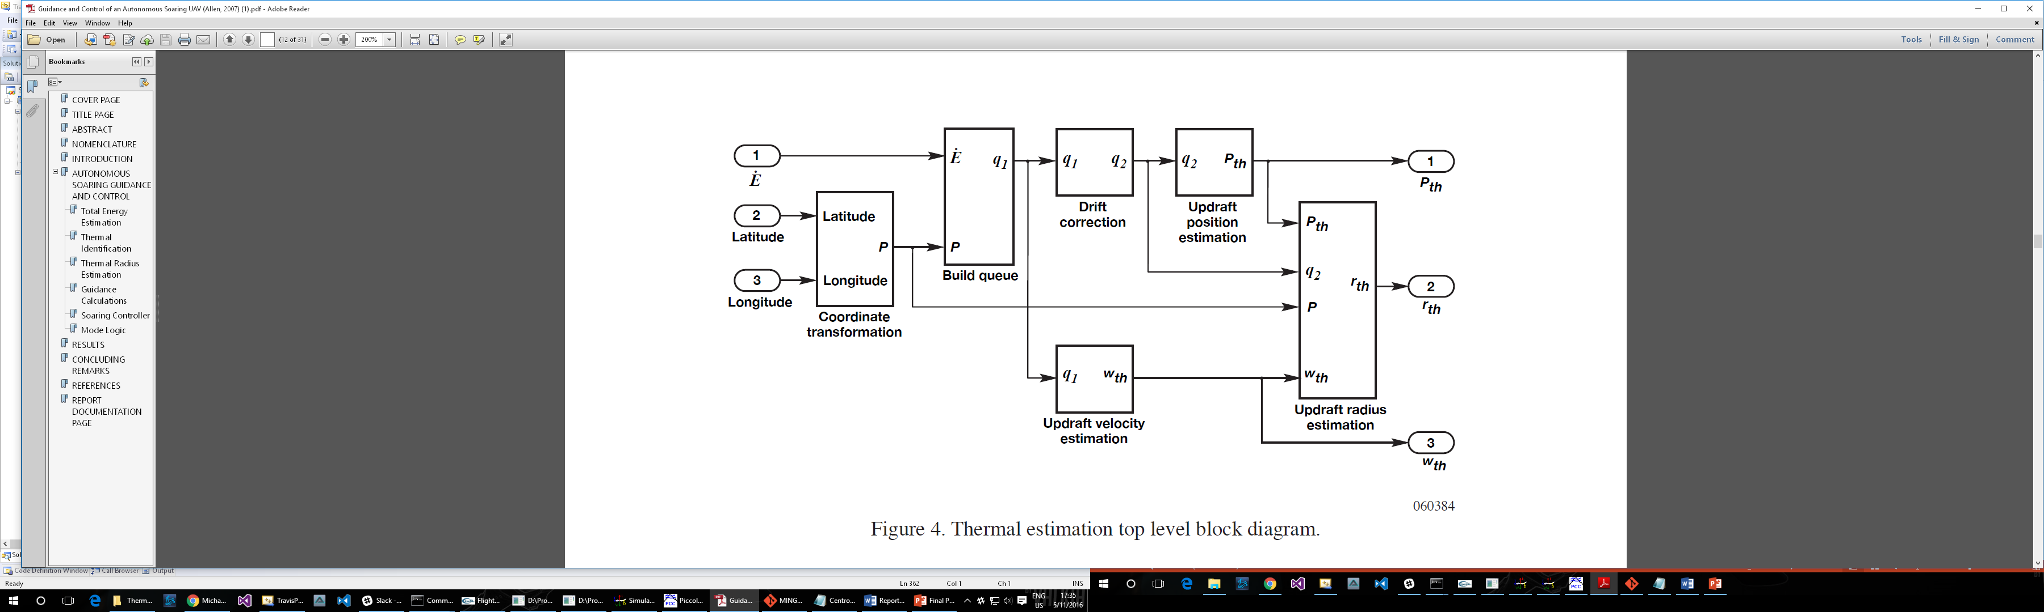

Figure 4 - Centroid Method Flowchart from Allen's Paper

Allen’s method is composed of some preliminary setup, then five basic steps. For preliminary steps, the latitude, longitude, and energy rate have to be put into a queue (or separate queues) that will hold this data for the last roughly forty-five seconds. With this structure set up and updating, the first main step of the method is to use each half of that queue to predict where the thermal is, this uses the process shown below.

$$Centerpoint=\frac{ \sum_{i=1}^{\frac{Queue Size}{2}}{Position\left[i\right]×Energy[i]}}{\sum_{i=1}^{\frac{Size}{2}}{Energy[i]}}×\frac{ \sum_{i=1}^{\frac{Queue Size}{2}}{Position\left[i\right]×Energy[i]}}{\sum_{i=1}^{\frac{Size}{2}}{Energy[i]}}$$

This process is done for each half of the queue, resulting in two different center points (these centerpoints are tuples, with a latitude and longitude value). To find the velocity (which is a two dimensional vector) of the drift the thermal is experiencing, we then do a bit of manipulation to those two points, as shown below.

$$V{}_{drift}=\frac{Center{}_{First Half}-Center_{Second Half}}{Time represented by half the queue}$$

This drift is then used to adjust the latitude and longitude data contained in the preliminary queues to create a final adjusted queue to use for calculations

$$Position\left[i\right]= V{}_{drift}×Time Step+Position[i]$$

The resulting queues then use a very similar process to the first section to estimate the final center point, which is then orbited.

$$Center=\frac{ \sum_{i=1}^{Queue Size}{Position\left[i\right]×Energy{\left[i\right]}^{2}}}{\sum_{i=1}^{Size}{Energy{\left[i\right]}^{2}}}×\frac{ \sum_{i=1}^{Queue Size}{Position\left[i\right]×Energy{\left[i\right]}^{2}}}{\sum_{i=1}^{Size}{Energy{\left[i\right]}^{2}}}$$

This is currently implemented in the C++ version of the code that uses the Piccolo simulator.

## Future Work

While the basic data processing and communication works well, there could be a lot of improvements to the presentation of the data. Ideally you would be able to view the datagraphed in real time as the aircraft runs, and be able to tweak parameters using a simple GUI interface.

In terms of the algorithm itself, any sort of filtering on the raw sensor data could be quite helpful to fine tuning the results. Because of its basic nature, there are significant well-studied improvements that could be made to the algorithm itself as well.

One more step to take would be to make a very easy selection process that would allow the code to seamlessly integrate with either the Piccolo or the Pixhawk autopilots, with only a simple startup command to make the difference. Currently we are in the process (which will continue this summer) of translating this algorithm into Python to run on the Pixhawk autopilot and simulator setup.

# Thermal Identification

## Overview

Our plane is flying along and the autopilot is sending sensor data such as position, velocity, airspeed, and ground speed at a constant rate to our computer on the ground. This data is then used for thermal identification, figuring out if the plane is in a thermal, and if so, what the thermal looks like. If the plane is not in a thermal, we want it to continue flying till it encounters one. When it does encounter one, we want to know that it has entered a thermal and then determine what the thermal looks like so the plane can be told to fly toward the region where the vertical velocity is highest, allowing the extraction of more energy from the thermal and thus enabling it to stay in the air longer.

We investigated three different probabilistic techniques that seemed promising for identifying thermals. In this project, there is much uncertainty due to us only having access to sensor data along the plane’s flight path, which when compared with the entire sky, is very small. This hints at the benefit of using probabilistic approaches, where we avoid throwing away data by taking only a point estimate – the same idea as not only providing the average of some data values but also the standard deviation.

The first technique is Bayesian parameter estimation, which tries to figure out what the parameters are for a given model. If the model is a Gaussian-shaped thermal, then the parameters are the amplitude, center position, and standard deviation. The parameter estimation will find probability distributions over all possible values for each of these parameters. Then, if desired, the most probable thermal could be computed or the entire probability distribution could be used in decision making.

The second technique, Gaussian process regression, does not require a model. Instead of giving a probability distribution over the values a parameter could take on, it gives a probability distribution over functions – how much does each data point look linear, parabolic, exponential, etc. The end result is function approximation. The regression takes input data and then interpolates and extrapolates to get all the values in between and beyond the input points. In this project, it is given the vertical velocity at discrete points along the flight path and from those estimates the vertical velocity in the region around where the plane has flown, which is then used to figure out if the plane has entered a thermal and where to circle when it does enter one.

A Bayesian network, the third technique, allows reasoning, i.e. performing inference, when working with multiple variables. Rather than just looking at vertical velocity to predict whether or not the plane has entered a thermal, we can incorporate additional sensor data so that we’re making use of all the information we have available. Vertical velocity seems like an important factor in thermals, since air rises in thermals. However, we have other data available such as air pressure and vertical acceleration that might be helpful in determining if the plane is in a thermal. Using a network, we could better utilize the limited data we have access to.

## Introduction to Bayesian Probabilistic Methods

### Review of Probability

The word "Bayesian" implies that we are going to be dealing with probabilities. Rather than knowing exactly what will happen if we are given all inputs to a system, where the outcome is a deterministic function of the inputs, we only know a probability distribution over the possible outcomes, where the outcome is a nondeterministic function of the inputs. This probability distribution takes on a higher value over more likely outcomes and lower values over less likely outcomes in addition to being normalized so the total area under the curve is one.

Remembering back to the probability and statistics class you have taken, below are the axioms of Probability Calculus, where $U$ is the universe of all possible events. (Korb 6, 2010)

$P(U)=1$

$∀_{X⊆U}P(X)≥0$

$∀_{X,Y⊆U}X∩Y=∅→P(X∪Y)=P(X)+P(Y)$

$∀_{X,Y⊆U}P(X∪Y)=P(X)+P(Y)-P(X∩Y)$



Figure 5. Thermal position probability distribution from Bayesian parameter estimation

Figure 5 shows an example probability distribution of where we think the center of the thermal is located. The distribution is higher where it's more likely to be and lower where it's less likely to be. Its width indicates how confident we are in its position. The blue curve is the $x$ coordinate and the green is the $y$ coordinate. Rather than saying the thermal center is at $(-15,10)$, we show how likely we think it is to be at each possible $x$ or $y$ value. The wider the distribution is, the less confident we are. The distribution is normalized such that the total area under the curve is one, as required by the first axiom.

In addition, there are two types of random variables: discrete and continuous. This is an example of a continuous probability distribution. The $x$ and $y$ variables can take on any values between $-∞$ and $∞$. However, Bayesian networks normally are of discrete variables. Frequently if continuous variables are needed to work with a Bayesian network, the inputs are discretized, grouping values into ranges, a technique that will be used in 3.7.4 to learn a Bayesian network.

In Bayesian networks the following definitions are important. The definition of conditional probability states how likely something is to occur given we know something else happened. (Korb 7, 2010) This definition is important here since it is used in Bayes' theorem.

$$P(X|Y)=\frac{P(X∩Y)}{P(Y)}$$

A variable is independent of another if the probability does not change whether or not you know another variable. (Korb 7, 2010) If the probability of $X$ is the same regardless of if you know $Y$, then $X$ is independent of $Y$. This definition is important since a Bayesian network shows dependencies in the arrows of the graph.

$$"X \text{is }\text{independent of }Y"≡P(X|Y)=P(X)$$

Finally, we can use Bayes' theorem to update our beliefs about a hypothesis as we gain new evidence, or information, over time. This theorem is what Bayesian probability is based upon. (Korb 12, 2010)

$$P(h|e)=\frac{P(e|h)P(h)}{P(e)}$$

### Bayesian Inference

In Bayesian inference, we are looking at two probability distributions. We start with a prior probability distribution, which is based on our present belief. What do we think the output of a function or system will look like when we give it different inputs? We may be more confident that it will look in a certain way than in other ways and thus give the probability distribution higher values over those outcomes. Then, we actually plug in some numbers to our function (which may, in fact, be moving a glider through space where we collect data at its new location) and look at what the outputs were. How close are these outputs to what we expected? Are we close or totally wrong? Using these observations of what actually happened, we come up with a posterior probability distribution, our new belief about what the function does. Through this process, we are updating our beliefs as we gain new information. (Korb 29, 2010) The mathematics behind this inference is based on Bayes' theorem.

Let's look at an example of Bayesian inference using Bayes' theorem from a presentation by Simon Wilson. Say we have a thermometer. We initially think that the temperature of a room is 18 °C. We'll say that our belief in this is a normal distribution with a mean of 18 and a standard deviation of 0.3. The width represents how certain we are, and in this case we think it is likely around 18, but it's not too unlikely that it could be up to 18.5 or down to 17.5. This is the prior distribution, shown by the black curve in Figure 6.

We then take two independent measurements in the room. If the two measurements we take are 18.1 degrees, our new belief is the red curve in Figure 6. If one measurement is 18.1 degrees and the other 18.4 degrees, then our new belief is the green curve. These new beliefs are the posterior distribution. (Wilson)



Figure 6. Bayesian inference for temperature measurements



Figure 7. Bayesian inference for flipping a coin

To see how beliefs can change over time as we gain more information, suppose we have a coin that is weighted so 20 percent of the time it lands on tails as shown in Figure 7. Initially, we're fairly unsure of the weighting, but think that it's likely about 0.5 since most coins are. As we flip it more times, on average we start getting closer to having a weighting of 0.2. Our posterior distribution moves from being around 0.5 with high uncertainty to being fairly confident it is about 0.2, as the distributions get more and more peaked.

## Bayesian Parameter Estimation

We can apply this theory of Bayesian inference to our project to estimate the parameters of a model for our thermal, i.e. performing parameter estimation. There is a Python library called PyMC3 that allows for easy prototyping while still being relatively fast. Rather than implementing all of this theory on our own, we chose to use libraries, such as PyMC3, so that we could make progress directly on the project rather than spending all our time implementing only the theory.

### Square Thermals

To start applying these Bayesian methods to our problem, let’s start off with very unrealistic assumptions, but assumptions that will allow us to get started estimating parameters of a very simple model:

* Thermals are square with a certain width and a constant vertical velocity.
* Vertical velocities can take on a value of either 0 or 1.
* There is only one thermal in our data.
* We know all the vertical velocities in some grid of a certain size.
* The positions are 2D coordinates, i.e. $(x,y)$ not $(x,y,z)$.



Figure . Square Thermal with All Knowledge

Figure . Square Thermal Parameter Estimation with All Knowledge

With these assumptions we can create a couple of square thermals, represented by the blue squares in Figure 8, where the vertical velocity is one in these squares and zero in all other squares. From this data we will try to find the position and width of a thermal with Bayesian parameter estimation. These will be the parameters of the larger of the two thermals in this data. The smaller thermal will just increase our uncertainty in the larger thermal’s parameters. In Figure 9 you can see the resulting probability distributions for the parameters. Individual samples from the probability distribution of the thermal position are displayed as semi-transparent red dots in Figure 8, indicating that a thermal is most likely centered in the region with the darkest red.

This is promising, showing that we can perform parameter estimation when dealing with very simple thermals. Though, one of our assumptions was not valid even in this example since there were two thermals. The parameter estimation found the larger thermal. An even larger issue is that we assume we know everything about the environment.

### Square Thermals with Partial Knowledge

Let’s revise our assumptions, making them slightly more realistic:

* Thermals are square with a certain width and a constant vertical velocity.
* Vertical velocities can take on a value of either 0 or 1.
* There is only one thermal in our data.
* We only know the vertical velocities along our UAV path.
* The positions are 2D coordinates, i.e. $(x,y)$ not $(x,y,z)$.

Now we have gotten rid of the all-knowing assumption. When using the actual plane, we will only have data available from our path through space, thus this second example is more realistic.

Figure . Square Thermals Positions with Partial Knowledge

Figure . Square Thermal Parameter Estimation with Partial Knowledge

In Figure 10 the black line represents the path of the glider, which while still unrealistic is more realistic than assuming we have all the data. Using only measurements along this path, we then again run Bayesian parameter estimation resulting in the probability distributions for the parameters shown in Figure 11. In Figure 10 you can see that the red dots are spread out more this time over the entire grid, meaning we are no longer as confident where the thermal center is. This seems reasonable since we are providing the estimation with less data now and much of that data is not within a thermal. The black path is mostly outside of the blue squares representing the thermals. This, of course, is still very unrealistic in that thermals are not square nor are their vertical velocities binary values.

### Gaussian-shaped Thermals

Let us change our assumptions to:

* Thermals are symmetric about the $x$- and $y$-axes and Gaussian-shaped with a certain center, amplitude, and standard deviation.
* There is only one thermal in our data.
* We know point measurements of the vertical velocity along our path at certain intervals.
* The positions are 2D coordinates, i.e. $(x,y)$ not $(x,y,z)$.

We will try to find the center, amplitude, and standard deviation of the thermal.



Figure 12. Gaussian-shaped Thermal Position

In Figure 12 you can see the path along the $xy$-plane in addition to the contour lines of the Gaussian-shape thermal surface above the plane. Also on the $xy$-plane are the red dots showing where the center of the thermal most likely is as was shown in the square thermal figures. The red dots are centered on the thermal much better than with square thermals and partial knowledge. The probability distributions for the parameters are shown in Figure 13, computed with the Bayesian priors for the parameters: uniform distributions from the minimum to maximum $x$ and $y$ values, from $-10$ to $10$ for the amplitude, and from $0.1$ to $100$ for the standard deviation.



Figure 13. Gaussian-shaped Thermal Parameter Estimation

In order to perform this parameter estimation, we needed to provide the discrete measurements along our flight path to PyMC3, the Python library used to perform this parameter estimation. The approach used here was to take $n$ measurements and feed them to the estimation. The estimation uses a sampling algorithm, where it tries different parameters seeing which result in the function taking on a value closest to our desired output. For each set of possible parameter values that are used in the sampling, it compares the $n$ measurements we’ve taken with its prediction of what these $n$ measurements would be if the model had the parameters we’re testing. Different algorithms can be used to choose the next sample, with the goal of fast convergence. The algorithm used here was the Metropolis-Hastings algorithm.

However, in all of this, we have been assuming a model. We started off with a very simple square thermal model and progressed to having a Gaussian-shaped thermal model. It is entirely possible that thermals in the real world may not fit our simplified models nicely. Another approach we could use is to take our input data and make predictions about what the world looks like nearby without assuming that vertical velocities are Gaussian shaped.

## Gaussian Process Regression

Gaussian process regression does not assume that the thermal looks like our model. It is function approximation: you give it inputs and it tries to predict what the function looks like both nearby the input data and also far away. In addition, since it is a probabilistic method, it also provides a measure of uncertainty. For instance, a prediction of what the vertical velocity is a kilometer away from our entire flight path will be much more uncertain than a couple meters away.

This uncertainty can be seen in Figure 14, showing how uncertainty decreases with an increasing number of data points in a region. On the left is our Gaussian-shaped thermal model as input to our regression. It does not have to be this simplified model, but this is an easy starting point. Later we will run this regression on simulation data. On this Gaussian-shaped thermal are black points showing the data that is provided to the regression, discrete samples of the function. Then, on the right is shown the results of Gaussian process regression done, trying to approximate the vertical velocity as a function of the $x$ and $y$ position.



Figure 14. Changes in Uncertainty with Number of Data Points in Gaussian Process Regression

The regression does not provide a point estimate, however. It again gives us a probability distribution over the predicted output value, and in this case a Gaussian distribution. There are three surfaces in the plots on the right. The middle surface is the mean of the estimate. Below and above are shown the 95 percent confidence interval. This gives an indication of the uncertainty. The closer the three surfaces are, the more confident we are in the output value. You can see that as we provide more data points, the surfaces get closer together, indicating we’re more confident in the predictions.

Up to this point we have been assuming no noise in the data. However, there will be noise in the data we’re collecting from the autopilot. To deal with this noise, we need to adjust the hyperparameters for our Gaussian process regression. For this regression, we are using a Python library called scikit-learn. It uses maximum likelihood estimation to figure out the parameters that maximize how likely it is that we would have obtained the data we provided to it as input. In addition, we have to provide what is called a “nugget.”

When working with regression, it is common to have some uncertainty in the input measurements. For example, when reading values off a volt meter, you only have obtained those measurements at a certain precision. When you’re doing least-squares regression in Excel on that data, it is not incorporating in the uncertainty in your measurements. With Gaussian process regression, through this nugget value you can incorporate your uncertainty in the measurements. It is also used to deal with numerical issues in performing the regression. Whatever nugget value is chosen, it is then added to the diagonal of the correlation matrix when used in calculations. (Andrianakis 4215, 2012)

In Figure 15, in the left two columns you can see the Gaussian process regression run with a nugget of 1e-10, a very small value. This is big enough to account for numerical issues in the calculations, but not large enough to properly deal with the measurement noise that was added here. All of the measurements had noise added to them drawn from a Gaussian distribution centered at zero with a standard deviation of $0.05$. You can see on the left that the predictions for the top two rows showing two different flight paths is problematic.

In the right two columns are the same flight paths but with a nugget of 1. The measurements again had the same noise added to them. The predictions look much closer to what one would expect given the input measurements.



Figure 15. Comparison of Gaussian process regression with a nugget value of 1e-10 (left) and 1 (right) for three different flight paths through a Gaussian-shaped thermal

We likely should pick the nugget value to use in our project based on data from the real world or at least simulation data. We will start by picking it based on simulation data. We want to pick it large enough to handle any noise in our measurements but small enough so that we don’t smooth out our function too much, which would result in a much too small prediction of the thermal strength, leading us to miss thermals in flight. The higher the nugget, the smaller the amplitude of our thermal we will detect due to this smoothing effect that is evident in Figure 16.



Figure 16. Picking nugget of Gaussian process regression through observing the smoothing of a simulated thermal. Nugget of 1e-10 (top left), 0.01 (top right), 1 (bottom left), and 10 (bottom right).

We recorded vertical velocity data as we were flying through a thermal in the Piccolo simulator. A $45$-second section of data including time spent in this thermal was then fed to Gaussian process regression. In Figure 16, you can see with a nugget of ${10}^{-10}$ the surface is very jagged but as the nugget is increased it looks more and more smooth. From this, it appears that a nugget of somewhere between $0.01$ and $1$ will be a good starting point.

## Comparison of Gaussian Process Regression and Bayesian Parameter Estimation

Bayesian parameter estimation and Gaussian process regression could both be used to figure out what a thermal looks like as shown in sections 3.3 and 3.4. We will try to compare them to figure out which is the most useful for our project. However, they are somewhat difficult to compare. Gaussian process regression predicts what the vertical velocity will be at each point in the $xy$-plane. It gives us a probability distribution over what values the function could take on at each of those points. The parameter estimation, on the other hand, gives a probability distribution over the three parameters of our simple thermal model, not over an infinite number of points in a plane. It is easy to visualize the normal distribution predictions of the regression through plotting three surfaces: the mean in the middle of the $95$ percent confidence interval, as was done in Lawrance’s thesis (Lawrance 144, 2011). It is easy to visualize the parameter estimation through plotting the probability distributions for each of the parameters. One possible way to make a direct comparison is through taking the maximum a posterior probability (MAP) estimate of each of the estimated parameters, i.e. taking the highest value of each probability distribution, and then plugging those into our model to get a surface. This produces similar plots but will likely result in the Bayesian parameter estimation surfaces being unsatisfactory since with high uncertainty the highest point isn’t representative of the entire probability distribution. Nonetheless, it is a simple way to compare the two methods even if we cannot draw too much from it. In addition to this MAP comparison, the probability distributions for each of the parameters are shown to the right in the following comparisons.

In Figure 17, a circular flight path around a thermal is shown. This flight path needs to be analyzed because we will likely circle or orbit in a thermal, extracting as much energy as possible in order to gain as much altitude as possible. The bottom row has ten times as many data points as the top row. This represents us using data provided from the autopilot at different rates, the top having a lower rate than the bottom plot. This gives a feel for how the two methods deal with uncertainty. In the first case, you can see that the regression has a high uncertainty through the three surfaces being far apart vertically. You can see the parameter estimation uncertainty through the probability distributions shown at right having large widths. These uncertainties decrease when we give the algorithms more data, as expected. In the Bayesian MAP plots, you can see that this is also evident through the red dots becoming more centered on the correct thermal center in the lower plot. Also note the poor results of taking a MAP estimate of wide parameter probability distributions.



Figure 17. Gaussian process regression compared with Bayesian parameter estimation flying in a circular pattern around a thermal

Because the Bayesian parameter estimation is assuming the thermal is perfectly Gaussian shaped, the contour lines on the $xy$-plane are perfectly circular in the MAP plots even though the input data is a sum of two Gaussian-shaped thermals, one with an amplitude of $5$ and a standard deviation of $10$ centered at $(0,0)$ and the second with an amplitude of $2$ and a standard deviation of $20$ centered at $(25,25)$. In the regression plots, the contour lines are not as uniform, showing how the regression is not assuming the input was based on our model. Gaussian process regression is picking up this smaller thermal as seen by the right side of the plot above the line $x=40$ having a peak around $y=20$.

In Figure 18, a straight-line flight path is shown hitting the edge of a thermal and not going through the center. This flight path needs to be analyzed since as we are flying along, we want to be able to detect that we have hit the edge of a thermal. It is more likely that we’ll hit the edge of a thermal than that we’ll hit the center (Edwards 2015, 24). In the bottom row, the parameter estimation estimates that the thermal amplitude is close to $5$, which is better than the $3.5$ in Figure 17. While the thermal position is estimated to be around $\left(20, -15\right)$, which is not correct, this is $74°$ from our path, only $15°$ from perpendicular. This is the direction in which we have uncertainty in our position parameter, which is apparent by looking at the red dots in the lower Bayesian plot. Uncertainty in the direction perpendicular to a straight flight path is reasonable since determining which side of you the thermal is on is mathematically unobservable if you are flying in a straight line (Edwards 2015, 24). Though, by adding more sensors to the glider to provide aileron deflection data, the direction of the thermal center has been determined in some tests with an 85 percent success rate (Edwards 2015, 24).



Figure 18. Gaussian process regression compared with Bayesian parameter estimation flying in a straight line near the center of a thermal

Now let’s look at how these methods compare when run on data recorded from the Piccolo simulator, which has a more complex thermal model – still Gaussian shaped, but also with down drafts around the thermal. This is similar to what will be discussed in section 3.6 but here we are using recorded data from the simulator rather than running it in real-time, meaning that the length of time to run the regression and estimation does not matter.

In Figure 19, you can see the flight path through the data points shown as red points on the $xy$-plane of the Gaussian process regression plots. The plane is moving mostly in the $x$-direction and very little in the $y$-direction. The position parameters were broken into two separate parameters instead of a two-dimensional parameter as in the previous Bayesian parameter estimations since here the input data is not over a square grid, so the prior beliefs here are uniform distributions that are different for the $x$ and $y$ positions.



Figure 19. Gaussian process regression compared with Bayesian parameter estimation on Piccolo simulation data

The parameter estimation appears to have picked up on the down drafts around the thermal and completely missed the updraft in the center of the thermal, which is what we care about most. This gives evidence of the main issue of this parameter estimation: it assumes a model. In this case, our thermal model did not correspond closely enough with that of the Piccolo simulator and gave us implausible results for our parameters.

Because Gaussian process regression does not require a model of the thermal, which is advantageous if thermals encountered by the plane in the real world are not Gaussian shaped, and because compared with Gaussian process regression, Bayesian parameter estimation is very slow, in this case approximately 50 seconds for each of these two parameter estimations, we decided to proceed with Gaussian process regression for the initial thermal identification algorithm.

## Gaussian Process Regression in Simulation

Now, let’s test Gaussian process regression in real-time on this more realistic thermal model that satisfies conservation of mass. If the air is rising in the center of the thermal, then the air must go somewhere. By assuming conservation of mass, you can calculate the downward air velocity around the rising air. (Allen 2005, 4) This is the thermal model used in both the Piccolo simulator and the CRRCSim simulator.

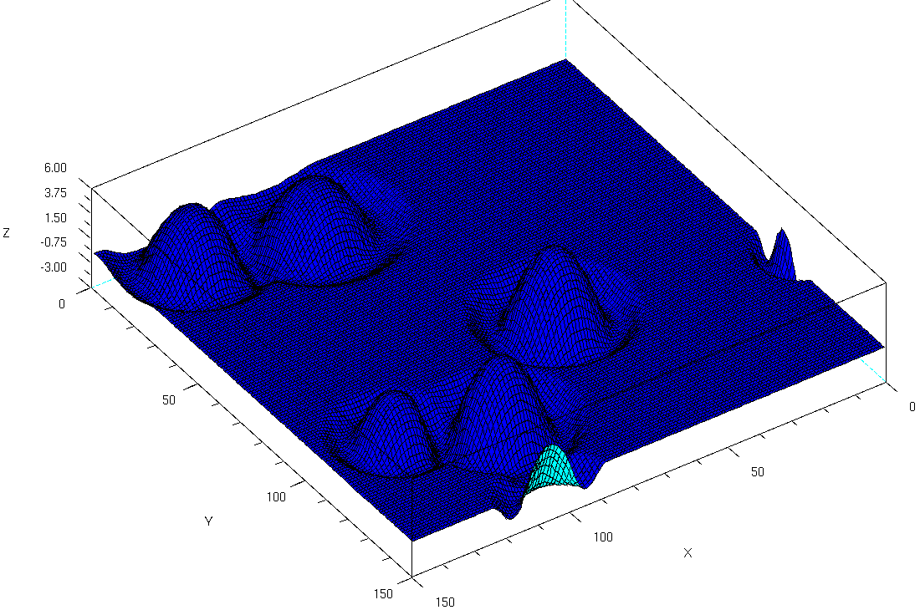

Figure 20. CRRCSim thermal model showing vertical velocity

The current approach is to have the plane in simulation fly the rectangular flight plans shown in the right of Figure 21 gaining altitude until it reaches an altitude of 200 meters above the starting altitude. It then cuts the throttle and starts gliding, recording vertical velocity data. It is continuously running Gaussian process regression on this data, trying to detect when it enters a thermal. This is shown by the plot on the left of Figure 21. Circled in blue is the highest point predicted in a region of about 20 meters in radius around the airplane. If this highest vertical velocity is greater than 0.5 m/s with 85 percent confidence, then it commands the autopilot to switch from auto mode, where it flies the flight plan, to guided mode, where it will now orbit the highest point with a radius of 5 meters. On the left you can see the red dots on the bottom of the plot, which represent the points the regression is being run on. It has so far orbited this thermal twice.

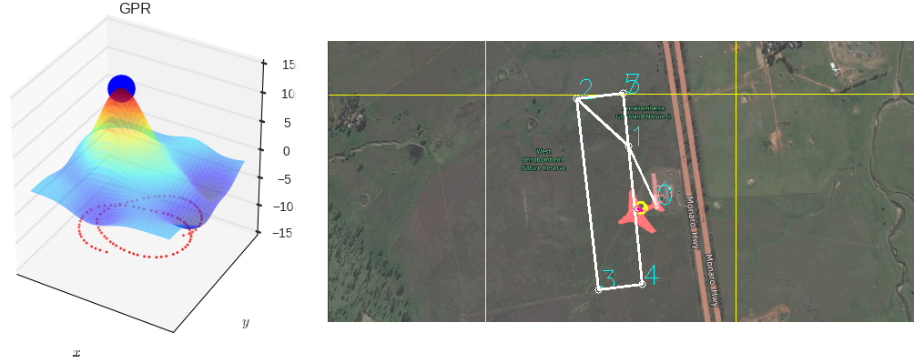

Figure 21. Gaussian process regression identifying a thermal in the CRRCSim simulator

In comparison with the centroid method that only gives a center location within the region you have been circling, here Gaussian process regression can predict what the entire thermal looks nearby. In addition, it can handle muliple thermals as shown in Figure 22. In this test, the plane flew through two close-together thermals. The Gaussian process regression was able to detect both of these. This could not be done with the centroid method, which calculates one center point.

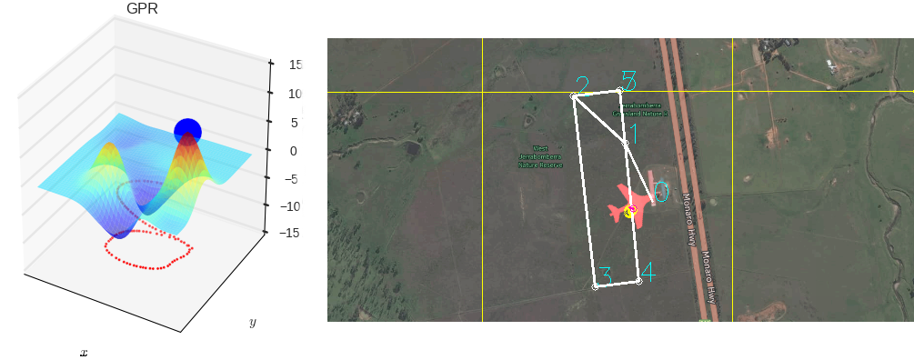

Figure 22. Gaussian process regression identifying two thermals in the CRRCSim simulator

## Bayesian Networks

### Overview

Up to this point we have been looking only at single variables. When we are interested in more than one variable and want to use the relationships between these variables, a Bayesian network can be used.

A Bayesian network is a graphical means to help you reason, i.e. perform inference, in the face of uncertainty. (Korb 29, 2010) In the network we will have many nodes, which are random variables, with arrows going between them. (Korb 29, 2010) The random variables are based on this idea of probability distributions. The arrows represent which nodes affect which other nodes. If we look at one node, its probability distribution is a nondeterministic function of all the possible inputs, which are the other nodes pointing to it. Now we are able to perform Bayesian inference on a larger scale. We now have prior or conditional probability distributions for each of the nodes. If the node has inputs, its conditional probability distribution is based on what values its inputs take on. If it doesn't have any inputs, then it has a prior probability distribution for what we think its outputs will look like. (Charniak 51, 1991) Now, when we make an observation and want to update our beliefs, rather than looking at a single posterior distribution, we can look at the new posterior probability distributions of all of our nodes.



Figure 23. Bayesian network

Figure 23 shows an example Bayesian network with three variables (AnAj). Whether it is raining affects whether we turn on the sprinkler, and both of these affect whether or not the grass is wet.

Through using a Bayesian network, we are able to work with more complex systems where different parts of the system are interrelated. We can reason forward for what will happen because of certain factors, e.g. determine what the probability is that the grass is wet when it is raining, or reason backwards to figure out what caused a certain event, e.g. determine what the probability is that it is raining if you look out and see that the grass is wet, depending on which nodes you observe. (Charniak 60, 1991) In addition, because of the prior distributions, we are able to find the new posterior distributions even when not given all the inputs to the system.



Figure 24. A dynamic Bayesian network (DBN) learned with CaMML from CRRCSim simulation data

It is also possible to integrate discretized time into a Bayesian network, which then is called a dynamic Bayesian network. This means that the variables at time $t$ influence the variables at time $t+1$. Figure 24 shows a dynamic Bayesian network learned from an RC plane simulation that will be further discussed in section 3.7.4. The computer learned that the throttle value at time $t$ affects not only the throttle value at time $t+1$ but also the pitch which affects the vertical velocity. So, as you throttle up, the plane starts to pitch up and also go up.

### Advantages of Bayesian Networks

This leads to the question: Under what circumstances would you turn to Bayesian networks as a tool? In other words, is this at all useful for this thermal soaring project?

First of all, since Bayesian networks are a probabilistic approach, they can be used to handle problems in which there is no clear-cut answer. There is some uncertainty. You are able to work with a probability distribution rather than a single output, allowing you to have an idea of how much uncertainty there is. Think back to when you've taken measurements and then averaged the numbers to get a single output. You lost information by doing this. Thus, you take the standard deviation of the sample mean as well, so that you have an idea of how spread out your data is. This gives you an idea of the uncertainty in your data. By having a probability distribution, you are following the same principle. For a given input, rather than saying the function will take on a certain value, you are saying how likely you think each of the possible outputs is. From looking at the probability distribution, you still have enough information to compute statistics such as the mean and standard deviation. You are left with more information than if you only approximated the function value with a single output.

Second, they allow you to make use of your prior knowledge about a system. You are creating the network, determining how the factors are related. In addition, you are creating prior probability distributions for each node in your network, as done in Figure 23. On the other hand, you also have the flexibility to do neither of these and just make lots of observations, i.e. record a lot of data, and then use that data to figure out what the network and prior probability distributions should look like, as done in Figure 24. (Korb 23, 2010)

Third, the network allows you to perform inference even when there is missing data because of these prior beliefs. For instance in the sprinkler example, Figure 23, because we have the prior probability distributions, you can ask what the probability is that the grass is wet even if you don't observe whether the sprinkler is on or whether it is raining. The network allows you to handle missing data.

For this project, we have very limited data, only data along our flight path. This means we have a lot of uncertainty about where thermals may be. Using all of the data we have available should allow us to better predict if we are in a thermal than if we only look at one piece of information such as vertical velocity data. Because of this, using a Bayesian network would be a good improvement over just running Gaussian process regression on vertical velocity data if the network takes into account other available data such as acceleration, air pressure, and especially aileron deflection as mentioned in section 3.5.

### Simple Example: Learning Conditional Probability Tables

In order to try out using Bayesian networks, we started with a simpler problem than thermal soaring: using a Bayesian network to make predictions of the next word in a message. You input in some words, maybe the first half of a sentence, and this program will try to predict what the next word might be, giving you possible next words and the probability that they are what you want to write next. The training data to learn the probability tables for the network will be the text file versions of public domain books from Project Gutenberg.

This is operating on the word level, not a character level. The observations provided to the network will be entire words, not portions of words. So, for instance, this network could not be used to predict the rest of a search query as done with Google's search suggestions based on words that are only partially written. It could likely be extended to do this, but this is merely a brief experiment used to learn how to work with Bayesian networks.



Figure 25. The BN used to predict the next word of a message for the case where n=3

This will use up to a fixed number of words as observations of network nodes to make the prediction. This number can be changed when learning the network. Figure 25 shows what the network would look like if we chose $n=3$. In this example, we have chosen to have three nodes in the Bayesian network, which will allow for two words (Word 1 and Word 2) to be used in the prediction. After the inference, we can look at the third and last node (Word 3) to see what will likely be the next word.

We will assume that a given word is dependent on all previous words in our network. In Figure 25 you can see that Word 3 has arrows pointing to it from each of the other words. It is dependent on both the first and second words. The second node is dependent only on the first node. And, the first node is not dependent on any other nodes.

Here we will not be worrying about execution speed. If this was actually to be used on a mobile phone or in a search engine, speed would be extremely important. However, getting something that works rather than something fast was the goal in this example. This might be an issue when trying to transfer this over to our project since even just using Bayesian parameter estimation was too slow to use live in the simulator.

The network is manually created, $n$ nodes with all later words dependent on all previous words. The probability tables can then be learned from the training data. We could split a book from Project Gutenburg up by paragraphs and then have a sliding window of $k$ words for $k=1, 2, …, n$. In the $n=3$ case, Word 1 has a prior distribution over all words (rather than a conditional probability table), the $k=1$ case, where we just look at how frequently each word is used. Then, Word 2 has a conditional probability table where Word 1 is given, the $k= 2$ case, where we look at how frequently a word follows another word. Finally, Word 3 has a conditional probability table where both Word 1 and Word 2 are given, the $k=3$ case, where we look at how frequently a word follows two other words. Then to go from frequencies to probabilities we divide all the frequencies by the sum of all the frequencies for each case. For example, in the $k=1$ case, we divide the count of how many times each word showed up in the book by the total number of words in the book.

A Python library called Pomegranate supports discrete Bayesian networks. After looking at an example for Pomegranate, it was easy to create a network of $n$ nodes, add the appropriate edges, and create the prior and conditional probability tables based.

Finally, after adding a way to query this network, you can on the command line interactively enter in words. It will take up to the last $n-1$ words to use as observations for the Bayesian network. It will perform the inference with Pomegranate and try to look at the posterior probability distribution of the last node in the network. If it succeeded, then the posterior distribution is sorted and the top results are output to the user. If it failed, then the number of words used to make the prediction is decreased by one until it succeeds or fails the $n=1$ case. It will fail if the sequence of words queried did not show up in the training data. In that case, we can't make a prediction since that word or sequence of words is not known by our system. We would need more training data.

If we train the network on Adventures of Huckleberry Finn, Alice's Adventures in Wonderland, A Tale of Two Cities, Frankenstein, Moby Dick, Pride and Prejudice, The Adventures of Tom Sawyer, and War and Peace, with $n=5$, we get:

>>> I know that

('this', 0.149)

('your', 0.066)

('to', 0.066)

('no', 0.066)

('he', 0.066)

('the', 0.066)

('I', 0.066)

('in', 0.016)

('at', 0.016)

('you', 0.016)

('either', 0.016)

('while', 0.016)

...

These results seem pretty reasonable. However, if we train the network on just Adventures of Huckleberry Finn, with $n=4$, then we get:

>>> I know that

('is', 0.5)

('island', 0.5)

Each one of these suggestions has a probability of $0.5$ because those are the only instances in the book where this phrase "I know that" was used. This shows how you need lots of training data if you want to make suggestions over a wide range of sentences.

The present program has a number of issues. First of all, when creating the network based on all the books with the $n=3$ case, it uses about 1.25 GiB of RAM and takes about 18 seconds. Then performing a prediction using two observed words takes about 13 seconds. This is much too slow for practical use. In addition, these results are all case-sensitive, meaning that a prediction based on "We are here" with $n≥4$ would be different than "we are here" (if $n=3$ then it would search for "are here" and the case of "We" would not affect the results). This may have been a bad idea when using only a small set of training data. With more training data this might be beneficial since you could predict proper nouns being capitalized for instance. Finally, we removed all punctuation except for single quotes and hyphens from words. Thus the prediction does not predict the end of a sentence and the beginning of a new one. Though, likely predicting the next sentence would need a larger $n$ since the next sentence probably requires more context for an accurate prediction. Overall, the results show potential but are far from actually being useful.

The major issue encountered in this simple program that will be problematic for our thermal soaring project is the length of time it took to perform the inference. We want to try taking live sensor data and then send new commands back fairly quickly. Taking 18 seconds might be too long since the plane may have passed entirely through the thermal by that point.

### Thermal Soaring: Learning the Network

In our problem, the network might not be so easy to write down based on intuition as in the word prediction case. However, it is possible to learn the network in addition to the conditional probability tables.

We recorded data from the simulator and used this to learn relationships in the data. In the data each subsequent row is at the next time step, so it is learning a network for how parameters at time $t$ affect parameters at time $t+1$. You can see in Figure 24 back in section 3.7.1 that it learned that the throttle value at time $t$ affects not only the throttle value at time $t+1$ but also the pitch which affects the vertical velocity. The idea here is that we may be able to better predict if we're in a thermal by using multiple parameters rather than just vertical velocity, extracting the most information as possible from the limited data we receive from the autopilot. For instance, if we were just using vertical velocity, we may predict we're in a thermal if we increase the throttle.

CaMML is free software available to learn networks from data that was used here. Simulation data was recorded in the CRRCSim simulator using the Python MAVLink interface. This data was then discretized since CaMML does not currently support continuous variables. CaMML can either learn a Bayesian network or a dynamic Bayesian network, and then it exports the learned network as a .dne file that can be opened in SamIAm, another free program. In SamIAm, you can create a new network and then also open the .dne file from CaMML and copy/paste into this new SamIAm network. Then SamIAm has an auto arrange function that allows for visualization of the network.

Beyond learning how to create Bayesian networks and how to learn them from data, this avenue was not further pursued due to lack of time. This is an opportunity for future developments.

## Future Work

Thermals are not stationary. This means that data collected in the last 5 seconds and 45 seconds ago should not be looked upon as having the same value. One possible way to incorporate how more recent data is more relevant is through using Lawrance’s separable squared-exponential covariance function for Gaussian process regression. In addition, scikit-learn does not allow for Gaussian process regression to be run on multiple data at the same point. This may make it difficult to use information from the last orbit around the thermal if the plane flies through the same position. This separable covariance function may also resolve this issue.

Presently the decision making in simulation just sets a constant radius around the highest point predicted by Gaussian process regression, which is assumed to be the thermal center. This radius is likely not ideal. In fact, in some simulation tests, if the thermal was small enough, the set orbit radius may keep the glider in the downdraft region continuously, which would result in the glider losing altitude rather than gaining altitude. The decision making algorithm could be improved to choose an ideal orbit from the vertical velocity predictions based on what would result in the highest energy gained and also not orbit a thermal if the plane would not be able to turn sharp enough to stay within the region of rising air. An alternative to developing this decision making is to integrate with the policy creation code described in section 4 which would automatically learn how to behave satisfactorily.

If Bayesian parameter estimation was to be explored further, a more complex model could be developed that may perform as well as or better than Gaussian process regression on the simulated thermals. If this were to be done, work would also have to be done to make the Bayesian parameter estimation run much faster.

Finally, as described in section 3.7, a future improvement would be to learn Bayesian networks on simulation data to incorporate more sensor data, and in particular, aileron deflection. Another option is more thermal research to figure out how to predict entering a thermal, by hand coming up with a network to incorporate this additional data.

# Creating a Policy

## What is a Policy?

A policy tells the unmanned aerial vehicle (UAV) what it should do, based on what the current situation is. More formally, a policy is a function from states into actions.

Some policies are better than others. For example, it would be useless to implement a policy that tells the UAV to always nosedive and crash-land! To capture this idea, we use the notion of a reward. When something good happens, we give the UAV a large reward. When something bad happens (for example, maybe the UAV crashes), then we give the UAV a small reward. In general, after each action the UAV takes we give a reward corresponding to how good the results of the action were.

The best policy is the one that gives the UAV the most possible reward. More formally, an optimal policy for a scenario is one that maximizes the learning agent’s expected value of reward for the scenario in question.

The notion of a reward may seem a bit abstract. In our case, we are interested in maximizing the energy that the UAV gets from the thermal. Therefore, we should reward something related to the energy the UAV has. As a first try, we are rewarding the height of the UAV, since this strongly correlates to energy. In the future, we plan to reward the total energy of the UAV, which includes energy from movement, energy due to height, and energy stored in batteries.

To summarize, a policy is a strategy the UAV follows to meet the goals we set for it. In our case, an optimal policy would tell the UAV how to maximize the energy it gets from thermals it encounters.

## Using the Policy: States and Actions

We have described a policy as a function from states into actions. As shown in Figure 26, the policy receives state information that tells it “What does the thermal look like?” and it outputs an action that is sent to the autopilot for actuation by the UAV. We next discuss the details of this state information and action information.

The input data consists of a model of what the thermal looks like. This model estimates the energy available from the thermal at each point. That is, the input data is a function from (x,y,z) position into energy values.

The action output by the policy is a high-level command interpreted and executed by the autopilot. Currently, the UAV can choose from the following actions: move closer to the thermal center, move further from the thermal center, or orbit at the current radius. An aspect of current work is to increase the number of actions that the UAV can choose from, allowing the UAV to take full advantage of the flexibility in policy formation offered by machine learning techniques.



Figure 26: The structure of our solution

## How to Form a Policy?

There are many ways to come up with a good policy for our thermal soaring problem. For example, the basic algorithm implemented as our baseline method works pretty well. For this senior project, we were was interested in learning how to use machine learning. Therefore, we sought out methods of forming a policy that use machine learning.

Machine learning is a huge, extremely popular, and rapidly developing field. Broadly speaking, if we say that an algorithm uses machine learning, we mean one or more of the following: the behavior of the algorithm can change over time, the algorithm can find patterns or structure unanticipated by the programmer, or the algorithm approximates an unknown function. Using machine learning allows the programmer to develop solutions to a problem that may be too complicated or time consuming to solve analytically.

It is appealing to use machine learning for our problem for two reasons:

First, we do not have a perfect model of thermal structure or behavior. As a result, it is difficult to determine an optimal policy for thermal soaring that considers non-ideal or dynamic effects. Since thermals can change over time, interacting in complicated ways with their environment, any thermal algorithm that cannot adapt over time will be limited in its effectiveness.

Second, the structure of our problem makes it amenable to a reward-based machine learning method. We can easily express the desired behavior of the UAV in the language of rewards. We simply reward the height of the UAV after each interaction with the environment. In many other design problems – such as designing a submarine – what the designers should reward is not nearly as clear.

## Learning about Machine Learning

We decided to using machine learning to develop a policy for our UAV. Unfortunately, there are no classes on machine learning offered here at Walla Walla University. In order to use machine learning, that meant we had to do a lot of work.

We took two steps to become somewhat familiar with a few machine learning methods:

First, one member of our team worked through *Reinforcement Learning: An Introduction*, by Sutton and Barto. This is a commonly referenced text on reinforcement learning, and is freely available online. We chose to work through this book because Lawrance uses a form of reinforcement learning for the thermal soaring problem. Further, reinforcement learning uses a reward-based approach, which works naturally with our thermal soaring problem.

Second, one member of our team took an online class called “Machine Learning” offered by Stanford online. This course consits of 11 weeks of material. Each week has about an hour of lecture, a quiz, and a three hour assignment. One member of our team entirely completed the class and received the certificate for it. The class covered a number of fundamental ideas in machine learning, including: linear regression, logistic regression, regularization, neural networks, machine learning system design, support vector machines, dimensionality reduction, anomaly detection, and large scale machine learning.



Figure : Machine Learning Course Certificate

## Choosing a Machine Learning Method

As mentioned above, there is a multitude of machine learning methods. If we restrict ourselves to the algorithms discussed in *Reinforcement Learning: An Introduction,* then we find there are two main methods. Both of these use a reward-based structure for learning.

The first method is “dynamic programming”. This is a very powerful method for finding good policies when we have a model of the system. Dynamic programming is reasonably simple to implement, and in some ideal cases it is guaranteed to converge to the optimal policy. However, a straightforward implementation of this method becomes computationally intensive for large systems.

The second method is “temporal difference learning”. Temporal difference learning methods are model free, which means we can apply them without having a good model of the system. As a result, these methods have a broader range of application than dynamic programming. Two of the most common temporal difference learning methods are SARSA learning and Q learning, and these algorithms are reasonably straightforward to implement. Getting these algorithms to work can be very difficult, however. This is because these algorithms have fewer guarantees on convergence, and their learning rate tends to be slower compared to dynamic programming, due to the lack of a good system model.

We began by using temporal difference learning. This is an appealing method due to its relatively simple implementation and its model free nature. However, we ran into function approximation difficulties associated with the model free nature of this method. That is, the learning rate was much lower, because the UAV did not have a model of what the thermal likely looked like. In addition, the nonlinear nature of the neural networks used to store the current policy information further compounded this problem. As a result, we eventually switched to using dynamic programming. Dynamic programming is an appealing method because it uses all the information we know about the thermal. That is, dynamic programming allows us to use all the model information estimated using Gaussian process regression (GPR).

## Implementing Machine Learning Methods: Overview

We needed a method of implementing machine learning algorithms in a programming language.

We had implemented a number of machine learning methods in MATLAB for the Coursera machine learning class, and so the first impulse was to implement the machine learning code in MATLAB. However, it appears that the machine learning libraries for MATLAB are purchased separately from MATLAB proper, and this was unappealing. In addition, we prefer to work with open source software when possible, and this was another strike against MATLAB.

Since MATLAB proved undesirable, and since the thermal modelling work was being done in Python, we chose to write the machine learning policy determination code in Python. We began by trying Google’s recently released machine learning platform called “TensorFlow”, and although we eventually met with some success, it was difficult to use. This was especially true because we were running Linux inside of Docker in order to use TensorFlow. Eventually we settled on a less sophisticated but easier to use machine learning library called “PyBrain”. This library is open source, although not actively developed. PyBrain provides support for reinforcement learning and for neural networks, which were the two key features we were looking for in a library.

## What is Dynamic Programming?

We have now discussed what machine learning is, and why we can apply it to our project. In order to understand the rest of our work, we need to explain the machine learning methods we applied in some more detail.

The first of these methods is dynamic programming. Dynamic programming is a method for developing a good policy for a reward based learning problem. To explain this method, we use an example that features a maze (see Figure 28). The learning agent is placed somewhere in the maze, and each interaction it can move up, right, down or left. There is no reward for anything except for landing on a red circle, (this gives a positive reward), or for trying to enter a wall (this gives a negative reward).

There are two major parts to the dynamic programming learning method:

The first major part is a “value function”. A value function tells the learning agent how good it is to be in a particular state if the learning agent follows the current policy. More formally, it is a mapping from policy-state pairs into values. Specifically, the value function maps a state into the expected total amount of reward that will be given to the learning agent starting from the state in question, if the learning agent follows the current policy. Figure 28 show the learned value function (below) for following the optimal policy (right) through the maze. Note that there are larger positive values closer to the goals (red circles). It is also worth noting that when estimating the reward under a policy, we weigh rewards that happen in the future less heavily.

The second major part to dynamic programming is a policy. As noted before, a policy tells the learning what to do based on the current state. In dynamic programming, we choose the policy to be “greedy” with respect to the value function. That is, the agent chooses to move to the highest value state it can on every interaction with its environment. This may sound shortsighted, but since the value function tells the agent the value in the long-term, this is actually a farsighted method.

Figure 28: Maze solved using dynamic programming (below: value function, right: policy)

We have introduced the two major components of dynamic programming: the value function and the policy. Now we describe how these parts interact. Here are the steps in the interaction:

1. We randomly initialize the value function and the policy.
2. We make the value function consistent with the policy.
   1. At every state, try out the action suggested by the policy.
   2. Record the resulting reward.
   3. Update the value of the current state accordingly.
   4. Repeat steps a, b, and c until our estimates for the values of all states converges.
3. We make the policy greedy with respect to the value function.
4. Repeat steps 2 and 3 until convergence is achieved.

Here are two important things to note about this procedure:

First, we need to have an efficient way of storing and updating both the value function and the policy. In a small problem, like the maze example above, it is feasible to store both of these using a lookup table. With larger systems (with many states or many actions), it is necessary to instead use methods that store a few parameters instead of the value function estimate or policy at every state. We call this technique “function approximation”.

Second, the dynamic programming steps presented above require determining the results of each action in each state. This is time consuming – prohibitively so as the system becomes larger. In addition, this requires a model of the system that allows us to predict the results of actions. To address the first problem, we try out every action at only a few states, develop estimates from these states, and then use function approximation to extend these estimates between these states. To address the second problem, we use a model of the system developed using Gaussian process regression (GPR), which we discuss earlier in this report. As a result, this method is limited by the accuracy of the GPR model.

## What is Temporal Difference Learning?

In addition to dynamic programming, we also used temporal difference learning to develop a thermal soaring policy. Just like dynamic programming, temporal difference learning is specifically for problems that can be described in the language of rewards. It is worth noting that we use dynamic programming, (not temporal difference learning), in the most current version of the policy development algorithm (as of June 2016).

We tried two temporal difference learning methods: SARSA learning and Q learning. In the following sections, we first present background concepts and then eventually explain SARSA and Q learning in detail.

### Interacting with the Environment

During each reinforcement learning iteration, the learning agent performs one or more interactions with the environment. For each interaction, the agent records the following: the initial state, the action performed, the resulting reward, and the final state. Afterward, the agent uses this recorded information to learn better behavior.

With respect to environmental interactions, there are two big differences between our implementations of SARSA and of Q learning.

First, in our implementation of SARSA, the learning agent performs only one environmental interaction before proceeding to the learning step. By contrast, in our implementation of Q learning the learning agent performs multiple interactions before proceeding to the learning step.

Second, SARSA is an on-policy method and Q learning is an off-policy method. This means that SARSA learns the Q values corresponding to the policy it uses for learning (which is likely suboptimal, since it includes exploration), while Q learning learns the Q values corresponding to the greedy policy. We present the notion of “Q values” below.

#### Exploration

We mentioned that the learning agent performs interactions with the environment, and that it uses this experience to learn. This raises a question: how does the learning agent choose which interactions to perform with the environment, in order to get experience?

It would be inefficient to perform all actions randomly, because this would result in the learning agent getting a lot of only somewhat relevant experience. It seems reasonable for the learning agent to try the actions it considers best – this will lead to interactions that are similar to those when the agent is actually performing (after having finished learning), and so the learning agent will get relevant experience. Unfortunately, if the learning agent only tries the actions that it thinks are best, its policy will generally become stuck at a perceived (fictitious) optimum. That is, there will generally be better actions that a greedy learning agent will never try because it is underestimating the value of these actions.

We try to strike a balance by having the learning agent generally carry out the action it thinks best, but to occasionally try a random action. This will result in relevant experience, but also allow the agent to explore new actions that it may be underestimating. We call this standard exploration strategy “greedy-ε”. On each environmental interaction, the learning agent chooses a random action with probability ε (typically a small number, like 0.05), and will otherwise choose the action it thinks is best, according to its current Q value estimates.

Figure 30 shows the effect of the value of the value of ε in a small demonstration program we created. In this scenario, there are several levers that the learning agent can pull, each of which will give some reward. Some levers give more reward than others. The red line shows what happens if there is no exploration (ε = 0). Note that in this case the learning agent becomes stuck at a suboptimal policy. The other lines show that the larger the value of ε, the faster the learning occurs, but the less optimal the final policy will be. For this reason, it is common to begin with a large value of ε, to obtain faster initial learning, and then to decreased the value of epsilon gradually – so as to avoid being limited in average performance by excessive exploration. We refer to this method of exploration as “decaying greedy-ε”.

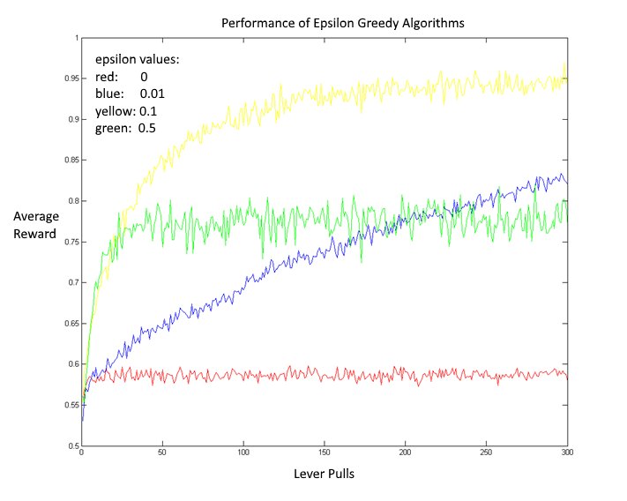

Figure : Effect of exploration on average performance

### Learning from Interactions: Q Values

After interacting with the environment, the temporal difference learning agent learns from the interactions it just performed with the environment. That is, it updates its estimate of the value of being in a state and performing a given action. These estimates are called “Q values”.

A Q value is a mapping from state-action pairs into values. The Q value of a state action pair called (S­1,A­1) is an estimate of how much reward will be given if the learning agent starts from state S­1, performing action A­1 and then follows the current policy. A policy that is greedy with respect to Q values is a policy that does the following: if the learning agent is in some state S, the chosen action is A*, where:



where A(S) denotes the set of actions that are possible in state S.

We need two more notions before we can present algorithms for updating Q values:

### Discounting

The first idea is called “discounting”. Discounting keeps value estimates finite, and captures the notion that reward now is better than reward in the future. The discounting factor γ is a number in the range . The higher the discounting factor, the more farsighted the learning agent becomes. To illustrate this idea, if the estimate of reward given at time is  (assuming that we start at time from some stateand follow some policy *P*), then the estimated value of starting in state and following policy *P* is then:

where indicates the action chosen in state *s* by policy *P*.

Notice that this implies:

Intuitively, this says that the value of being in a state and doing some action is the reward the learning agent will get right away, plus the (discounted) estimated value of the state that the agent lands in next.

Note that we have assumed (for simplicity) that the environmental interactions are deterministic. In general, the sum for estimated value should in each term include the possible rewards that could occur, weighted by the probability with which they could occur. As an example of a non-deterministic system, consider the case in which the learning agent is a small cart, and the environment is a slippery floor. If the cart chooses to go forwards, perhaps there is an 80% chance it will actually go forwards, and a 20% chance its wheels will just spin in place.

### Learning Rate

The second idea is called the “learning rate”, which we denote by α. After a set of environmental interactions, we need to incorporate new information gained, but we should not discard the previously learned information. To strike a balance, we take a weighted average of the old Q estimate and the Q estimate based on the most recent interactions:



The learning rate is simply the weighting factor α that determines the extent to which we incorporate the new estimate. If α is too small, the learning process takes unnecessarily long. On the other hand, if α is too large, then the learning algorithm may not converge. Slow or chaotic convergence can also be indicative of a learning rate that is too large.

### A Temporal Difference Learning Algorithm: SARSA Learning

In our implementation, SARSA performs only one interaction with the environment before updating its Q value estimates. Here is the notation we use to describe this interaction:

* The learning agent begins in state 
* The learning agent then performs the action 
* The learning agent ends in state , where it plans to next perform 
* The learning agent is given a reward of 

SARSA chooses actions by following a policy that is ϵ-greedy with respect to the Q values it has determined so far. As a result, the Q values SARSA learns will reflect the fact that the agent is exploring while learning – and these Q values will generally not be the same as the Q values for the greedy policy.

We now give the learning update equation for SARSA learning. This equation combines the ideas of discounting and of a learning rate:

Notice that we have expressed the estimated Q value based on the new interaction as a sum of the reward given, and the estimated (discounted) value for the next state.

Here is a summary of the SARSA learning algorithm:

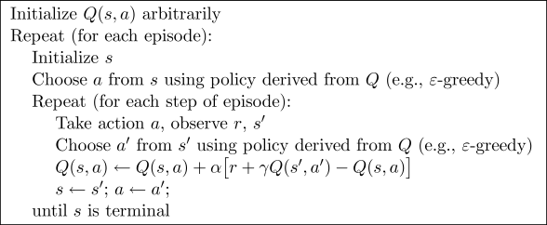

Figure : Summary of SARSA Learning Algorithm (Sutton 6.5)

Notation: s refers to a state, a to an action, r to a reward, and γ is the discount factor

### Another Temporal Difference Learning Algorithm: Q-Learning

In SARSA learning the Q value of the next state action pair is estimated using the Q value of the state action pair that next comes next under the current policy. Note that this policy will generally not be a greedy policy with respect to current Q function estimates (but will include exploration). This means that under SARSA, the learning agent learns the Q value of states under the current policy. However, this is not always desirable. This is because, while learning, the learning agent needs to make an effort to explore, and so it sometimes tries suboptimal actions. Therefore, one could argue that we are most interested in the Q value of state action pairs when the agent is operating under the greedy policy, and not exploring.

Q learning allows the learning agent to get estimates of the Q value of state action pairs under the greedy policy, even when the agent is performing the environment interactions under a different policy. For this reason, Q-learning is called an “off-policy” method.

The update algorithm for Q-learning is just the same as for SARSA learning, then, except that we converge towards the Q estimates under the greedy policy instead of the current policy. So, the estimated value for the next state is in terms of the maximum Q value for the next state:



Where:

* The learning agent begins in state 
* The learning agent performs the action 
* The learning agent ends in state 
* The learning agent is given a reward of 

Here is a summary of the Q-learning algorithm:

#### https://webdocs.cs.ualberta.ca/~sutton/book/ebook/pseudotmp9.png

Figure : Summary of Q Learning Algorithm (Sutton 6.5)

#### Batch Based Learning

As mentioned above, our implementation of Q learning carries out multiple interactions with the environment before carrying out any learning. We refer to the number of interactions before learning occurs as the “batch size”.

On each interaction, we record the initial state, action taken, reward given, and final state. After we have completed the specified number of interactions, then we learn from all of this new information at once. That is, we do all the Q value updates that we could have done after each iteration all at once. Note that batch based learning reduces to an online learning style when we set the batch size to one.

## Initial Model Generation and Hill Climbing

We can now discuss the process of designing a machine learning algorithm for thermal soaring. In order to understand the most recent (and most successful) form of the algorithm, it is instructive to look at the steps taken along the way. Examining older methods and understanding why they were insufficient explains our design choices in the most recent form of the algorithm.

As a first step, we created a simple model of the thermal in MATLAB, and then added interactivity between the UAV and thermal in the form of basic hill climbing.

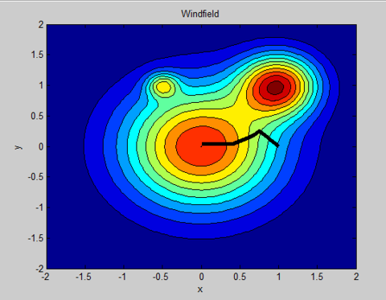To create a model of the environment, we modelled our thermals as circularly symmetric and Gaussian shaped. (Note that this is a gross oversimplification). Three parameters define such a thermal: its position, its strength (its value at its central point) and its size (standard deviation along any cross section). Figure 32 shows a contour plot of a generated system with three thermals (warmer colors indicate a greater thermal value).

Figure : Three thermals with hill climbing. The black line show the path of the UAV as it moves to an area of higher thermal strength.

Figure 32 also shows the output of a rudimentary hill climbing algorithm. Note that the UAV began in an area of low thermal strength and then moved towards an area of high thermal strength. The purpose of developing this algorithm was to demonstrate that the model UAV could move and interact with its environment in a somewhat intelligent way.

We implemented the hill climbing algorithm in the following way. On each time step, the algorithm looked at the thermal strength in a grid of locations near the UAV. The algorithm determined the position with the highest thermal strength and moved the UAV to the new location. Note that this is a shortsighted, greedy policy, and does not in general result in the UAV moving to the region with the greatest thermal strength, as is illustrated in Figure 32. Also note that this method requires the UAV to have a model of the system.

## Initial Classification and Regression

The hill climbing algorithm is a very simple policy for using the energy from thermals. That is, at every point, the hill climbing algorithm tells the UAV in which direction to go. At this point, we knew that as the environment became more complicated, we would need to have an efficient way to save our policy, using something called “training examples”.

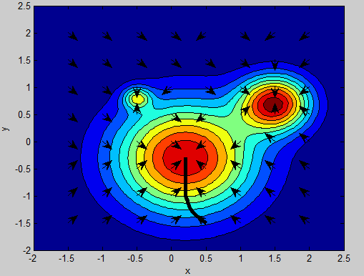A training example for a policy consists of two things: a known input, and a corresponding desired output. Figure 34 shows a grid of training examples (arrows) corresponding to the hill climbing policy. We use training examples to store a policy using a neural network.

Figure : Training examples for hill climbing policy

One method of storing a policy efficiently is to use a neural network. This seemed like a practical choice, since there are good libraries to implement neural networks, neural networks are very flexible, we learned about neural networks in the Coursera Machine Learning class.

A neural network is of the form shown in Figure 35. Each circle corresponds to a neuron and each connecting line has a weight associated with it. Each neuron has an activation function associated with it. The activation function maps to the total input of a neuron to its output. Each neuron in the network generally has the same activation function, except for the output layer neurons, which have an application specific activation function.

The output of a neuron *n* is given by applying the activation function *A* on all the input into a neuron, where each input is multiplied by the weight of the path that connects it to neuron *n*:



Training a neural network involves two steps. First, one must create a number of training examples. Each training example consists of an input and a desired corresponding output. The second step is to modify the weights of the neural network so that the neural network can correctly replicate the training examples. That is, a trained neural network can produce the output of a training example upon being provided with its input.

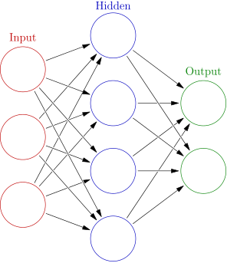

Figure : The form of a neural network   
By Glosser.ca - Own work, Derivative of File:Artificial neural network.svg, CC BY-SA 3.0, https://commons.wikimedia.org/w/index.php?curid=24913461

For our hill climbing policy, the training examples were the arrows shown in Figure 34. That is, given a position, we wanted our neural network to output the correct direction to travel in. Then, to save the entire policy, it would only be necessary to save the weights in the neural network instead of the value of the desired policy at every point.

In order to have the output of the neural network indicate the desired travel direction, we put the same number of neurons in the output layer as the number of possible travel directions. The output of the neural network was interpreted as follows: whichever output neuron had the largest output, that was the direction the neural network thought the plane should travel in.

Figure 36 shows the results. The overlaid dots represent the training examples, where each color represents a direction. The underlying color show the output generated by the neural network. The neural network divided its policy decision regions in approximately the right places, but it failed to include a number of the smaller (but still important) details.

The neural network was unable to replicate the complicated decision regions presented by the training data. Adding additional layers and additional neurons to the network did not seem to fix this problem (although it seems that it really should – this may be worth looking into further). Unsatisfied with this method of storage using a neural network, we experimented with a different method of storing the policy.

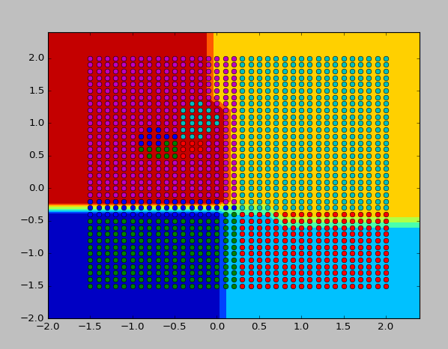

Figure : Poor neural network classification results

At this point, we were unsatisfied with the results of the attempted classification by the neural network. Still looking for a good method of storing a policy, we next turned to regression.

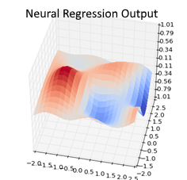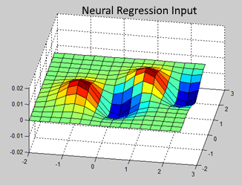In the regression problem, the training examples have only one output, which corresponds to some sort of value estimate. As shown in Figure 37, we had greater success getting a neural network to perform regression. The image on the left shows the plot generated when the training examples are plotted, and the image on the right shows the (scaled) output of the neural network.

Figure : Successful neural regression.

Left: the training surface. Right: the (scaled) learned surface:

To illustrate the process of getting a neural network to perform regression in the PyBrain library, consider the XOR example below. The first few lines of code show how a set of training examples is built up, by adding both the desired input and the desired output. The next line of code shows the syntax for constructing a neural network with 2 input neurons, 10 hidden layer neurons, and 1 output layer neuron. The “hiddenclass” argument refers to the activation function of the neurons in the hidden layer. They command line output shows results of training, with the input on the left, the desired output in the middle, and the actual output on the right. Regression was successful in this example.

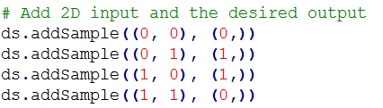



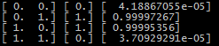

Figure : XOR regression example

## Understanding PyBrain’s Structure

At this point, we had generated a basic Gaussian thermal model in MATLAB, and successfully trained a neural network to store value information about a given scenario using regression. Some of the code was in MATLAB (model generation and evaluation), and some was in Python (neural network training). At this point, we decided to switch everything over to Python, since the model estimation using Gaussian process regression was also in Python. This meant we needed to learn how to do model generation and evaluation using Python.

As discussed earlier, we eventually chose PyBrain as our Python machine learning library. Upon transitioning to Python, we began by manually implementing and visualizing the thermal as in MATLAB. However, we soon realized that PyBrain also has the capability to facilitate environmental modelling and interaction. As an added bonus, PyBrain has a number of reinforcement learning methods already implemented. For these reasons, we decided to do the policy development work entirely within the structure of the PyBrain library.

PyBrain is documented somewhat sparsely, but it is open source. In order to understand how it works, we spent a great deal of time crawling through its source files and dissecting the example code provided. As an added challenge, David had never programmed in Python before.

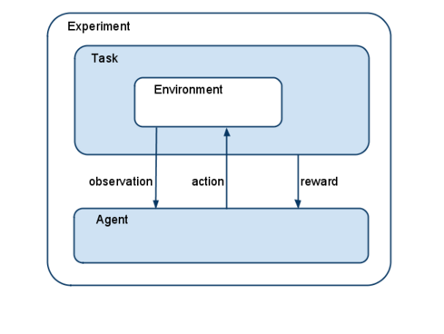After much work, we learned how to use the PyBrain library. Figure 39 shows the basic learning structure in PyBrain. The environment contains the model information, such as the state of the UAV, and the size and position of the thermal. The environment is able to update the state of the UAV based on commands given by the UAV. The agent in our case is the UAV. The agent has a policy, a learner, and an explorer. The policy tells the UAV what to do in each state, the learner helps improve the UAV’s policy, and the explorer tells the UAV when to explore when interacting with the environment. The task separates the environment from the agent, acting as a sort of a buffer. It controls what information in the environment is observable, and what commands from the agent are allowed to influence the environment.

Figure : PyBrain learning structure (http://pybrain.org/docs/tutorial/reinforcement-learning.html)

## Using PyBrain: Table-Based SARSA

Using our new understanding of the PyBrain learning library, we were able to implement a table-based SARSA learning algorithm. “Table-based” refers to the fact that the Q value estimates are stored in a table in this method. Each row in the table corresponds to a state, and each column corresponds to an action.

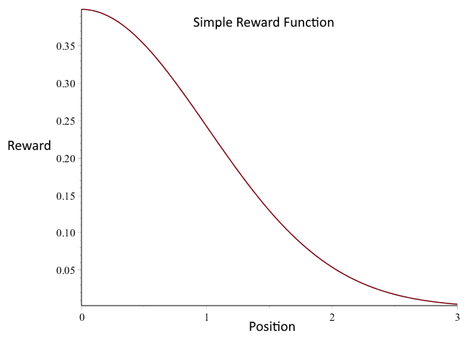The rewards were awarded according to a reward function, as shown in Figure 40. A reward function is a mapping from states into rewards. The maximum reward is given at the center of the thermal. This implies that the optimal policy would have the UAV move towards the center of the thermal and stay there.

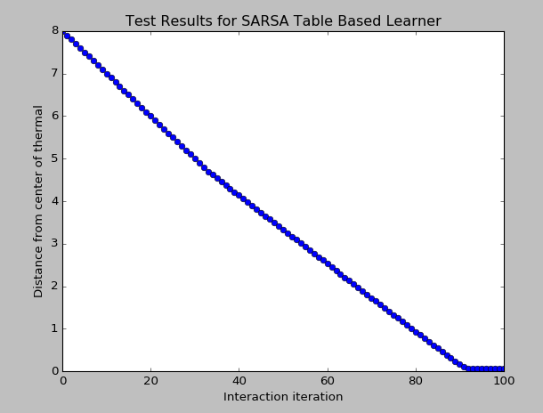The test results for a table-based SARSA learner with the above reward function are shown in Figure 41. The UAV moved towards the center of the thermal and stayed there, as desired. In this test, the UAV was only given a handful of directions it could travel in, so as to keep the size of the state-action space manageable.

Figure : Table-based SARSA learner succeeds in a highly simplified environment

Figure : Reward function for Gaussian shaped thermal at origin

As we increased the number of actions available to the UAV, and as we decreased the coarsness of the discretization of the state space, the results became less desirable. As shown in Figure 42, the policy developed in this test was far from optimal, and the UAV in fact never reached the center of the thermal. (The horizontal red lines show the discretization of the state space).

The reason the algorithm began to have difficulties as the state-action space became larger was because of the table-based method of storage for the Q value estimates. The larger the state-action space becomes, the more entries in the Q values table needed to be filled in correctly.

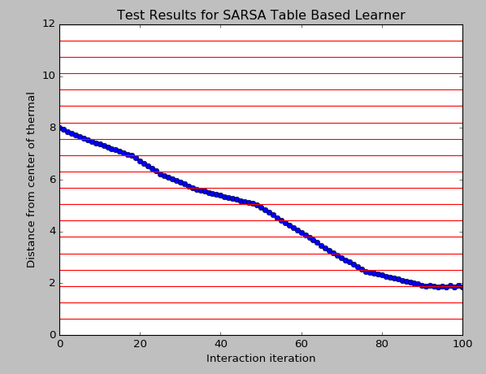Ideally, we would like the UAV to have a nearly continuous policy, not a coarsely discretized one. This would require a massive lookup table, and would require very long training times. Our attempt at a solution to this problem is to use a form of function approximation.

Figure : Large state space scaling difficulties with table-based SARSA

Function approximation refers to the practice of estimating a function from a smaller number of a values or parameters. If we could train a neural network on a few key entries in our table of Q values, then it could make estimates for all the millions of entires in the table that would be too time consuming to fill out. As a proof of concept, we trained a neural network on the entries in Q value table used in the SARSA learning process. As shown in Figure 43, this test had encouraging results. Using regression, the neural network was able to replicate the performance of the UAV following the table based method, even showing slight improvement.

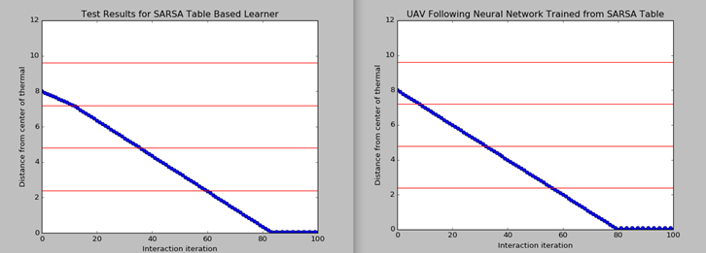

Figure : Neural network successfully trained on Q values table

## Function Approximation with Neural Fitted Q

Encouraged by the ability of a neural network to approximate the Q value table used by the SARSA learner, we next attempted to eliminate the table and to store the Q values in a neural network. This method is called “neural fitted Q learning”.

PyBrain has a neural fitted Q learner already implemented. Unfortunately, after several weeks of frustration, we had to move on to other ideas, since the Q values only rarely converged to what they should be. One difficulty was that of modifying the neural network to reflect new Q estimates, while retaining older learned Q estimates. Using the new information as the sole basis for training examples means the neural networks forgets all its old estimates. In an attempt to fix this problem, we trained the network on a combination of new estimates and old estimates, and this noticeably stabilized results. Unfortunately, this perhaps stabilized training results too much, and the learning seemed to proceed at a glacial rate, if any learning occurred at all.

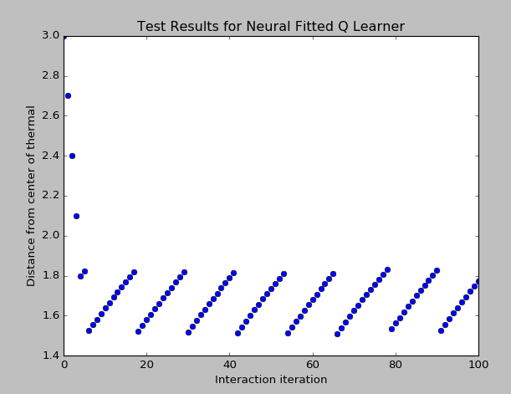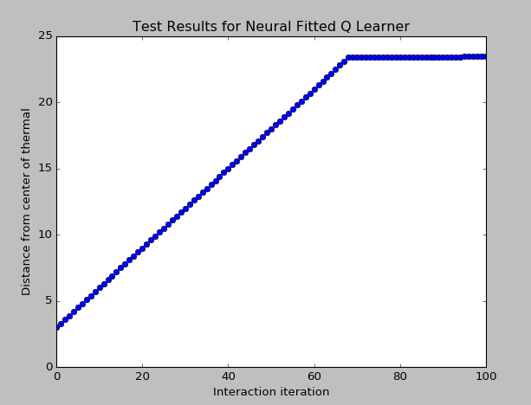Figure 44 shows a couple of the baffling simulation results we encountered while debugging the neural fitted Q learning algorithm:

Figure : Baffling neural fitted Q learning simulation results

After consulting with a number of professors and trying a number of possible fixes, we decided we needed to move on to a different method. While another method based on dynamic programming did end up working better (as discussed later in this report), we should note there are a couple advantages of this method.

The first advantage is that the neural fitted Q method is model free. That is, it does not require a model of what the thermal looks like or how the UAV interacts with the thermal. By contrast, dynamic programming does require such a model.

The second advantage is that this method does not involve iteration over many states and actions (as is required by dynamic programming), and the training is focused on relevant state-action pairs (since these are encountered during environmental interactions). For these reasons, this method seems likely to scale up reasonably well.

## Dynamic Programming with Function Approximation

We were unable to get neural fitted Q to work properly, despite much debugging. A new method was required. Since the problems seemed to be arising from function approximation, we decided to skim through *Reinforcement Learning and Dynamic Programming Using Function Approximation* by Busoniu, Babuska, Schutter, and Ernst.

From this book, we got the idea to combine dynamic programming with function approximation. Originally, we had considered dynamic programming impractical, because we were under the impression that it necessarily involved storing value estimates and policy estimates for each state. However, it dynamic programming can also be done using function approximation.

Recall that dynamic programming involves developing a value function and a policy. The value function estimates how good it is to be in a state, while the policy tells the learning agent how to move from state to state. Using neural networks, we can use function approximation to store both the value function and the policy.

If we are using neural networks for dynamic programming, we need to determine what we will use for training examples. We decided to select a few states evenly spaced throughout the state space, and we refer to these states as the “training states”. At these training states, the value estimates are updated as per normal. Every learning iteration, the updated value estimates at these training states are used as training examples for the neural network, which then saves the updated value estimates. Due to the continuous nature of neural networks, the value network can also give value estimates at all other points in the state space.

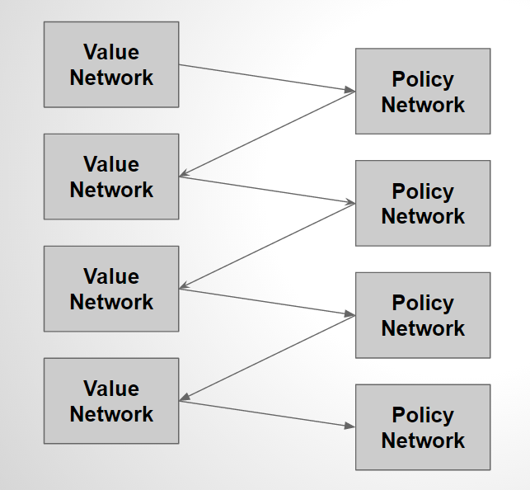We also train a policy network on every learning iteration. For training examples, we use the greedy actions at the training states. Due to the continuous nature of neural networks, the policy network can interpolate and provide a suggested action at every point in the state space.

Just as in regular dynamic programming, the value function and the policy update each other, as is illustrated in Figure 45.

An advantage of this method is that it uses any model information we have available (recall that dynamic programming requires a full model of the system). This is also the disadvantage of this method. If the model of the system estimated by Gaussian process regression is not very accurate, then this fundamentally limits the ability of this learning algorithm. Neural fitted Q (discussed earlier) would not have this limitation.

Figure : The value network and policy network update each other

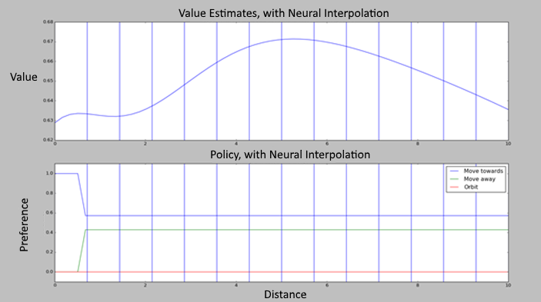While debugging this method, we found that the value network trained correctly, but the policy network did not. That is, the policy network was not greedy with respect to the value network after each learning iteration. Some of the bizarre output that resulted is shown in Figure 46:

Figure : Policy network not training properly

The top graph shows the output of the value network, where the x-axis is distance from the center of the thermal and the y-axis is value. This is a Gaussian (ring shaped) thermal with its greatest value 5 units from the center of the thermal, and so the output of the value function is plausible.

The bottom graph shows the output of the policy network. The blue line shows the preference of the learning agent to move towards the origin (left), the green line shows the preference of moving away from the origin (right), and the red line shows the preference of orbiting (no movement). The x-axis is position, and the y-axis is preference, with the top line being the decision taken by the UAV at each point. This policy network suggests the UAV should always move towards the center of the thermal, which is inconsistent with the value network above.

Completely resetting the policy network after each learning iteration fixed this problem. It turned out that the weights in the policy network had been growing without bound, which resulted in instability and strange overfitting problems.

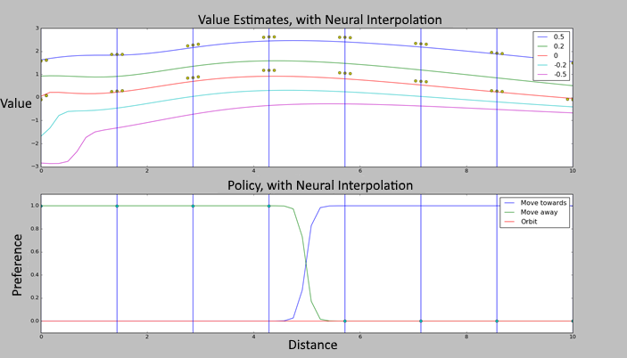After we fixed this problem, the value and policy networks in the same scenario converged to the results shown below:

Figure : Reasonable value and policy network results

Notice that the UAV moves towards the area with the greatest thermal strength, as it should. The different colored lines in the upper graph show the estimated value at different heights, as indicated by the legend. Notice that the highest elevation lines have the greatest value, as they should since we are rewarding the height of the UAV.

## Adding Direction Information; Debugging with Linux

In order to facilitate faster debugging, we modified the learning algorithm to run on Linux. We also told the algorithm to regularly save debugging images instead of outputting them to the screen. As a result, we were able to run the program on several computers at once simultaneously by using SSH to access the computers in the Linux Lab.

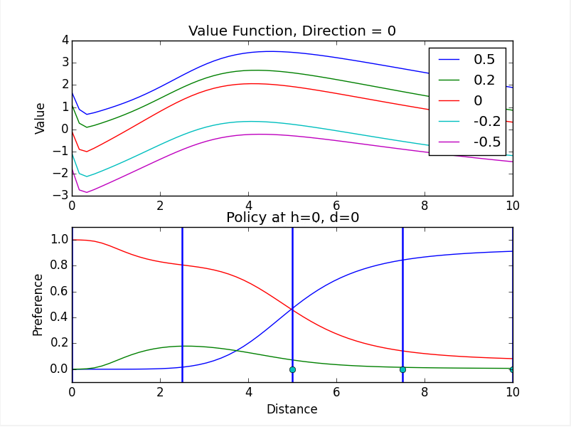Using this greater debugging speed, we were able debug and test value and policy development on thermals in different locations, taking into account the following UAV states: distance from center of thermal, height of UAV, and direction relative to thermal (whether the UAV faces the center of the thermal or not). While cleaning up and debugging the files, we corrected a number of dubious coding practices, and the speed of the algorithm increased by about a factor of 10x.

Figure : Example debug image output by algorithm running by SSH on Linux lab computer.

In the policy, red = orbit, blue = go towards origin, and green = go away from origin.

In these plots, the UAV is facing the origin. See previous debug plot explanations.

In adding direction information, we also added a penalty for switching directions. This reflects that a real UAV cannot turn around without a loss of height. As a result, the UAV now chooses to get close to the center of thermal strength, and to then begin orbiting, as show above. If it is placed closer to the origin, facing the origin, it will choose to orbit instead of turning around and incurring the resulting penalty. This behavior seems plausible and desirable.

## Transitioning to CRRCSim

We are in the process of getting the most recent algorithm to run in a much more sophisticated simulation environment called CRRCSim. This simulator is free and open source, which makes it appealing. It runs most easily on Linux, and so we have installed Ubuntu in a virtual machine, and have installed Python and all the required Python libraries on this virtual machine. We are in the process of installing CRRCSim on this virtual machine.

## Future Work

Dynamic programming with function approximation seems to be working properly in a simplified environment, where there is a very limited number of actions and an ideal (and completely known) thermal. The next step is to integrate with a simulator and observe the performance of the algorithm in a more complicated environment, and when the model of the system is estimated using Gaussian process regression (GPR) instead of being totally known.

Currently we use neural networks for function approximation. Neural networks may be excessively flexible for this task – a linear combination of carefully selected features would likely be both faster and less prone to interpolation difficulties. There are standard model based reinforcement learning methods that use other methods of function approximation – these would be worth investigating. For example, an adaptive tile based method (similar to the table based method discussed before) sounds very promising.

We attempted to use neural fitted Q and did not get it to work. However, the method is very appealing due to its model free nature and its ability for scaling. It would be worth returning to this method to at least understand better why it was not working.

The next step is to get the currently most successful algorithm working with CRRCSim. After doing this and evaluating the results, we will most likely seriously investigate a model free tile based method. We hope this method will not be over reliant on the GPR model, while at the same time being reasonably fast and flexible (due to its linear nature).

# Autopilot and Hardware

## The Plane

In Figure 48 you can see the glider that will be used for thermal soaring. The fuselage of the plane is hollow, so the autopilot will be placed beneath the black hatch, right behind the motor.



Figure 48. Glider built by the mechanical team shown with all the seniors of the electrical/computer and mechanical team.

## Switching from Piccolo to Pixhawk

While we are using the Piccolo for simulation, we decided to go with the Pixhawk for actual flight. We have a Piccolo Nano, but after sending data to Michael at CloudCap during the 2014-2015 school year, he thought there might be hardware issues with it, and it is primarily designed for quadcopter flight anyway. We also have a Piccolo SL, which we got since for the 2014-2015 project with the Vertical Take-Off and Landing UAV, we needed to use version 2.1.4, which didn't run on the Nano. This can be used for fixed-wing flight. However, the wiring harness has very long wires (not ideal for a lightweight glider) and also doesn't bring out the CAN bus, which is needed for hardware-in-the-loop. In addition, for autonomous flight we might need to create an AVL model. In other words, getting the Piccolo up and running seems like it would be a lot more complex and time consuming than using the Pixhawk, and we used the Pixhawk last year for similar reasons. It's really simple to set up.

## Connecting with the Piccolo Simulator

### Networking Motivation

The Piccolo software includes libraries that can be linked against with the Visual Studio 2008 C++ compiler, but not any other. Because this is proprietary, closed-source software, we cannot get access to the source to build it with any later version of Visual Studio. Thus, we have to use this old version of Visual Studio to work with the simulator. This means that we’ll be limited to C++ functionality that was available in 2008.

Our higher-level algorithms have been developed in Python, which means that we will need to develop some method of interfacing between the C++ code that sends data to and receives data from the Piccolo simulator and the Python code that will be operating on this data and sending commands. One possibility would be to try working at a low level, creating a Python module in C or C++. However, because the Piccolo only runs on Windows and one of our team members doesn’t have Windows but is using Linux, using a network connection for the communication would allow having the Piccolo simulator running on one computer and running the higher-level code on another computer. In addition, this fits in with the Piccolo simulator design, where it is using TCP connections to talk between the simulator, ground station, and Piccolo Command Center. Thus, we decided to proceed with this networking option.

### Network Protocol

On the C++ side is the connection to the autopilot. We want the C++ side to send the data it receives from the autopilot to the Python side. We want the Python side to then send commands back to the C++ side to forward on to the autopilot. We could make either side the server, but since the C++ side is connecting to the autopilot, it makes sense to start that first as the server and then have the Python side connect as a client to the C++ side.

Both sides will have to agree on the format of data they are sending and receiving. A simple mechanism for doing this is to use JSON, which is a simple string-based format that supports working with objects, arrays, integers, floating-point numbers, etc. We are wanting to send and receive named floating-point values, so JSON will be sufficient.

We will be sending many messages from the C++ server to the Python client and from the Python client back to the C++ server as shown in Figure 49. After sending some data, the other side will have to know when a specific message has been completed. One way to do this is by having a delimiter that is used to signal the end of a message. Since our strings will not be containing the null character (‘\0’, i.e. a zero byte), this makes for a good delimiter. The C++ server will send each message received from the autopilot through the TCP connection followed by this null byte. The Python client will receive the bytes from the TCP connection and wait until it has read a null byte to decode and process the received message. The same will occur in the opposite direction.



Figure 49. Network communication overview of C++/Python interface.

Here is a sample message of data sent from the server to the client:

{

"type": "data",

"time": 1461537758,

"lat": 0.803670378365061,

"lon": -2.06629154723287,

"alt": 500,

"velDown": -2.362356346634,

"IAS": 2.1742068576,

"TAS": 2.8273059504,

"energy": -600.236845235

}\0

Here is a sample message of a command sent from the client to the server:

{

"type": "command",

"lat": 0.803670378365061,

"lon": -2.06629154723287,

"alt": 500,

"radius": 10

}\0

However, fields can easily be added or removed.

### C++ Server

A commonly-used C++ networking library is Asio. There is a Boost and non-Boost version of this library. These provide the same functionality, but the Boost version can use Boost’s threads, lamda expressions, etc. rather than the C++11 (or later) implementations. Since we are using C++ functionality only from 2008, we will not be able to use C++11 threading and other features, so we will use Boost.Asio and get these features from Boost. Using this library, the actions show in Table 3 will be implemented.

Table 3. Server connection actions.

|  |  |
| --- | --- |
| **Action** | **What Occurs** |
| Open | When a client connects, a TCP connection is opened. |
| Send | When new data is available, it is sent out to all connections. |
| Receive | When the client sends commands back, they are sent to the autopilot. |
| Close | The connection is closed when either the client or server finishes. |

This C++ program will be multithreaded so that sending and receiving data over the network will not interfere with sending data to and receiving data from the autopilot over serial or over the network. Two thread will be started to handle all the communication with the autopilot: one to send data to the autopilot and one to receive data from the autopilot. One more thread will be started for the C++/Python interface server. This is illustrated in Figure 50.

A data structure with locking will be used to manage the data between all three of these threads. The autopilot receiving thread will add data to a queue in this data structure every time it receives new data from the autopilot. This data will be buffered up to a certain maximum number of entries and sent to new connections that connect so that new clients will immediately receive the most recent data upon connecting. Then additional data will be sent to these connected clients as the autopilot receiving thread receives more data.

The encoding and decoding of the JSON will occur in this locking data structure. When data is written to the TCP connection it will be converted to JSON using the RapidJSON library, chosen since it does not require C++11 features. When data is read from the TCP connection, it will again use this library to decode the command.



Figure 50. Data and command flow through the C++ server of the C++/Python interface.

### Python Client

Python has networking modules, so we do not need to go looking for a library to use. We can import “socket” to connect to the server and import “select” to wait on a socket until it is ready to send or receive data. Finally, the JSON encoding and decoding can be done by importing “json.” Using this built-in functionality, the actions show in Table 4 will be implemented.

Table 4. Client connection actions.

|  |  |
| --- | --- |
| **Action** | **What Occurs** |
| Connect | When the Python script is started, it will try to connect to the server. |
| Receive | When data is sent from the server, the Python client will receive this data into a queue. |
| Send | When the client has new commands to send, they will be added to a queue that will be sent back to the server. |
| Close | When the Python script is terminated, the TCP connection will be closed. |

The Python client will run both in multiple processes and multiple threads. Because of Python’s global interpreter lock (GIL), we will use multiple processes so that the data processing can run simultaneously with the sending/receiving of data in the C++/Python interface. As in the C++ server, a data structure with queues will be used to store the data received and the commands to send. This data structure will use deques created through a Python SyncManager that will handle sending the data between the two processes. One process will be started that will run all the data processing, which includes thermal identification and decision making. Another process will be started that will start two threads: one to receive data from the C++ server and one to send commands to the C++ server. This is illustrated in Figure 51.



Figure 51. Data and command flow through the Python client of the C++/Python interface.

In networking receiving thread, whenever the C++ server sends data over the TCP connection, this thread will add that data to the data queue. The next time the processing process is finished processing the last batch of data, it will pull all this new data to use in the next run. After the processing completes processing one batch of data, it will add a new command to the command queue, which will notify a condition variable. The networking sending thread is waiting on this condition variable. It will then wake up and send the new commands in the queue until there are no more commands to send, at which point it will again go to sleep until it’s notified there are more commands to send.

## Connecting with the Pixhawk Simulator

The Pixhawk and APM Plane use the MAVLink library to send and receive data. This library provides a Python script that will generate code to allow the library to work with languages such as Python, C, or C++. With this generated code and the MAVLink Python “pymavlink” library, we can connect to the Pixhawk USB telemetry radio or the simulation.

The communication with the Pixhawk either in simulation or over the USB telemetry radio is very similar to the Python code connecting to the C++/Python interface shown in Figure 51. The only difference is the networking code is using the MAVLink library instead of the “socket” Python module. Figure 52 shows the connection with the simulation, and Figure 53 shows the connection with the live Pixhawk through the USB telemetry radio.



Figure 52. Data and command flow between the APM Plane simulation and the Python processing process.



Figure 53. Data and command flow between the Pixhawk and the Python processing process.

# Conclusion

## Ethical, Political, Sustainability, Manufacturability, Social, Health and Safety, Environmental, and Economic Concerns

While not a directly controversial project in most conceivable categories, there are some concerns to be aware of when considering potential application of our work this year. As with any project that increases the duration of glider flight, there are definite militaristic applications concerning the effectiveness of both surveillance and more direct interventions by UAV. More likely to be a concern for this particular project is the additional duration could allow hobbyists to go places they should not be and invade the privacy of others.

These others could be a government project or other political organization, and with the recent laws regarding drone flight, having gliders circling autonomously in thermals could raise political concerns. In terms of manufacture, care must be taken when creating any fiberglass structure, but this part of the project does not impact that a great deal.

Social concerns are perhaps slightly more interesting. With the predator drones under the military’s control, a circling glider could be easily seen as either a surveillance vehicle or potentially lethal UAV by the general populace. Whenever an objects seems to be circling a person that person will feel a bit nervous, and that could potentially happen more often with this sort of thermal soaring approach.

This project should not have serious impact on the health and safety of individuals, beyond any normal autonomous glider precautions. The possible worries would be that the project would cause the failure of the autopilot system, or would allow it to soar out of range of signaling on a thermal and potentially crash at another location.

If a glider did crash at a location that was either inaccessible or not able to be located, that would cause some environmental damage. However most of the project was geared towards using less resources to further protect the environment. Likewise, it is designed as a more economical way to fly, and thus should not have significant economic impact besides perhaps increasing interest in glider production.

## Concluding Remarks

The initial goal for this project was an autonomous glider that could use thermals in the atmosphere to soar for longer periods of time and travel longer distances. While this goal has not yet been reached, it is we believe within grasp by the end of this year. The steps that remain are to switch our code over to working with the Pixhawk, and get the Pixhawk autonomously soaring with that code. While not simple steps in and of themselves, they are quite a bit more straightforward than the previous steps of this process and can be tackled in a forthright manner.

This project has been a great learning experience for all of the project members involved. At the start of the project, there was a great deal of discussion on what exactly to do this year. Planning out the project and then splitting it into parts that each member had an interest in took careful thought and consideration. The structure we eventually planned on has worked well for us, and next year’s group may want to consider something similar.

Starting off with a great deal of research let us make intelligent decisions regarding our initial project outline, and then starting one member on the task of implementing a basic version of what we were attempting provided a framework that let the other parts of the project quickly become integrated as the results of our research reached fruition.

This research and implementation of different methods provided us with a broad understanding of the field of thermal soaring and current autonomous methodologies. While none of our results are ground-breaking, the understanding they have provided us with of fascinating concepts such as machine learning could give us an advantage in our future roles in the industry and higher research.

Overall the project has expanded our horizons both academically and in terms of teamwork and project planning. While we do not currently have our full solution flying, our simulation results appear to confirm the validity of our work, and it should translate well to the glider the mechanical team has built. We have high hopes for the additional work we can complete before the end of the quarter, and we look forward to seeing how our theories perform in reality.

References

Allen, Michael J. "Autonomous soaring for improved endurance of a small uninhabited air vehicle." *Proceedings of the 43rd aerospace sciences meeting, AIAA*. 2005.

AnAj. *A Simple Bayesian Network*. Digital image. *Wikimedia Commons*. 16 Sept. 2006. Web. 25 Apr. 2016. <https://commons.wikimedia.org/wiki/File:SimpleBayesNet.svg>.

Andrianakis, Ioannis, and Peter G. Challenor. "The effect of the nugget on Gaussian process emulators of computer models." *Computational Statistics & Data Analysis* 56.12 (2012): 4215-4228.

Charniak, Eugene. "Bayesian networks without tears." *AI magazine* 12.4 (1991): 50.

Childress, Christopher E., "An Empirical Model of Thermal Updrafts Using Data Obtained From a Manned Glider. " Master's Thesis, University of Tennessee, 2010.

Edwards, Daniel J. *Autonomous Locator of Thermals (ALOFT) Autonomous Soaring Algorithm*. No. NRL/FR/5712--15-10. NAVAL RESEARCH LAB WASHINGTON DC, 2015.

Korb, Kevin B., and Ann E. Nicholson. *Bayesian Artificial Intelligence*. Boca Raton, FL: CRC, 2010. Print.

Lawrance, Nicholas RJ. *Autonomous soaring flight for unmanned aerial vehicles*. Diss. University of Sydney, 2011.

Wilson, Simon. “Tutorial on Bayesian learning and related methods: A pre-seminar for Simon Godsill’s talk.” *Trinity College Dublin*. n.d. Web. 30 May 2016. <https://cs.tcd.ie/disciplines/statistics/statica/statica_web/Wilson_Bayes_seminar.pdf>.

Appendix A – Autopilot and Simulator Setup

## A.1 Pixhawk Simulator Setup Guide

Guide created on 4/17/16

Okay so I’m doing this with a pretty much clean install of Ubuntu 14.04.

**First things first, installations:**

Open a terminal (Ctrl+Alt+T) and type:

sudo apt-get update //to update everything

sudo apt-get install python3

sudo apt-get install python2.7 // to make sure all the pythons are available to be tamed.

sudo apt-get install python-dev

sudo apt-get install python3-dev

sudo apt-get install libevent-dev //Now we should be ready to develop too

sudo apt-get install pacman

sudo apt-get install git

Go here: <https://github.com/thermalsoaring> and see if there are any changes that have been made since this guide was created

**Git setup:**

git config --global user.name "John Doe"  
git config --global user.email johndoe@example.com

Except of course replace them with the actual git account you’re using

Next we’re going to clone in the current thermal soaring repositories

git clone <https://github.com/ThermalSoaring/bayesian-learning.git>

git clone <https://github.com/ThermalSoaring/autopilot-communication.git>

// As more are finalized, would be cloning more here

**Slack:**

If you are communicating via slack, download that now if you want: <https://slack.com/downloads>

The slack for our team is thermalsoaringuav

**Testing the autopilot-communication base setup:**

So before more things happen, let’s test. Follow these instructions:

Installation:

Add '~/.local/bin' to your PATH, so that APM's sim_vehicle.sh script and

can find mavproxy.py.

Do this with:  export PATH=$PATH:~/.local/bin

Now do the following in the autopilot-communication folder.

Mavlink:

    $ git clone https://github.com/mavlink/mavlink

    $ cd mavlink/pymavlink

    $ python2 setup.py build install --user

Now make sure you’re back in your root folder, then to the following:

Mavproxy:

    $ sudo apt-get install python-wxgtk2.8

$ sudo apt-get install libopencv-dev

    $ git clone https://github.com/Dronecode/MAVProxy mavproxy

    $ cd mavproxy

    $ python2 setup.py build install --user

Now make sure you’re back in your root folder, then to the following:

Ardupilot:

    $ git clone https://github.com/diydrones/ardupilot

Now edit the run_demo.sh script, set the APM variable in that script to point to where you cloned the ardupilot.

$ cd crrcsim

$ gedit run_demo.sh (or vim, etc)

For this guide it should be:

APM="../ardupilot"

Now go up a level and install crrcsim-apm:

$ sudo apt-get install build-essential xorg-dev libudev-dev libts-dev libgl1-mesa-dev libglu1-mesa-dev libasound2-dev libpulse-dev libopenal-dev libogg-dev libvorbis-dev libaudiofile-dev libpng12-dev libfreetype6-dev libusb-dev libdbus-1-dev zlib1g-dev libdirectfb-dev

$ sudo apt-get install libsdl-image1.2-dev

$ sudo apt-get install libportaudio-dev

$ sudo apt-get install libplib-dev

$ sudo apt-get install libjpeg62-dev

$ sudo apt-get install libboost-all-dev

$ sudo apt-get install libcgal-dev

$ apt-get install python-software-properties  
 $ add-apt-repository ppa:schot/gawk  
 $ apt-get update  
 $ apt-get install gawk

Now go back to the root of the original folder (where you cloned the autopilot-communication)

$ git clone <https://github.com/tridge/crrcsim-ardupilot.git>

Then follow the directions in documentation/compile.txt and install.txt

Now cd to autopilot-communication/crrcsim, and run the demo shell script we modified earlier

$ ./run_demo.sh

You should see “Waiting for heartbeat” and it will clone the entire world and install it.

This is installing the actual simulator/etc that we’ll need for the open source stuff we’re messing with.

Once it works you should see something like this



It flies, crashes, then calibrates everything.

Congratulations!

## A.2 Piccolo Setup Guide on Windows for Thermal Soaring

This document will describe how to set up the Piccolo simulator, how to setup our C++ application, how to setup the Python side, and how to setup the Pixhawk.

### A.2.1 Installation

The Piccolo simulator supports thermal simulation, which will be very useful for getting our project to work without the added complexity of testing it only in a real environment.

On the Google drive you'll find two installers (you don't need the multirotor one since we're simulating a fixed-wing):

Piccolo/Piccolo-2.2.3.b.R19774/Piccolo-Installer.r19774.msi

Piccolo/Piccolo-2.2.3.b.R19774/Piccolo-Installer-Developer.r19774.msi

### A.2.2 Running the Simulator with Thermals

Run Piccolo 2.2.3.b/SoftwareSimLauncher.bat

When Piccolo Command Center (PCC) starts, go to File --> License Manager and add a file. Use the *Piccolo/WallaWalla-License.xml* file.

#### A.2.2.1 Visual Studio Project Setup

The Piccolo software includes libraries that can be linked against with the Visual Studio 2008 C++ compiler, but not any other. Thus, we need to use this old version of Visual Studio to work with the simulator. This means that we'll be limited to C++ functionality that was available in 2008.

#### A.2.2.2 Download the C++ Thermal Soaring code

git clone https://bitbucket.org/wwuthermalsoaring/thermal-soaring

#### A.2.2.3 Install Visual C++ 2008 Express

This is needed since the Piccolo's CommSDK dll's are compiled with Visual Studio 2008 and we need to use the same compiler so we can link against them.  
[Visual Studio 2008 download](https://go.microsoft.com/?linkid=7729279)

Then, since you can't register it anymore, crack it (????):  
[Stackoverflow](http://stackoverflow.com/a/30540370)

#### A.2.2.4 Download Boost for Boost threading, since we can't use C++11 thread as 2008 < 2011

**Download the msvc-9.0-32.exe and install somewhere, e.g. C:\boost_1_60_0**

[Direct 32-bit download](https://sourceforge.net/projects/boost/files/boost-binaries/1.60.0/boost_1_60_0-msvc-9.0-32.exe/download)  
[Sourceforge binaries](https://sourceforge.net/projects/boost/files/boost-binaries/1.60.0/)

**Downloading RapidJSON**

Extract somewhere, e.g. to C:\rapidjson-1.0.2  
[Rapid JSON 1.0.2](https://github.com/miloyip/rapidjson/archive/v1.0.2.zip)  
[All Rapid JSON releases](https://github.com/miloyip/rapidjson/releases)

#### A.2.2.5 Adding paths/libraries to Visual Studio

**Add environment variables:**

BOOST=C:\boost_1_60_0

RAPIDJSON=C:\rapidjson-1.0.2

**Right click on the project --> Properties --> Configuration Properties --> C/C++ --> Additional Include Directories:**

$(BOOST);$(RAPIDJSON)\include;

**Right click on the project --> Properties --> Configuration Properties --> Linker --> Additional Library Directories:**

$(BOOST)\lib32-msvc-9.0;

### A.2.3 Python Setup

The GPR and Reinforcement Learning algorithms have been developed using Python, a higher-level language than C++ that allows for easier and faster development and prototyping. The easiest way to set this all up on Windows is using Anaconda as explained below.

#### A.2.3.1 Setting up Anaconda for Python 3.5 and many Python libraries

**Download and install the Python 3.5 compiler for Windows 64-bit:**

[Download](https://www.continuum.io/downloads)

**Install additional packages:**

conda install seaborn

**Getting the Python Thermal Soaring code**

After starting the Piccolo simulator and the C++ side of the C++/Python interface, which includes the server, you can start the Python client that will connect and run the GPR thermal identification:

git clone https://github.com/ThermalSoaring/thermal-soaring

cd thermal-soaring

Next, in the Visual Studio project, change the arguments when running the program. Right click on the project --> Properties --> Configuration Properties --> Debugging --> Command Arguments: -a gpr. This will then listen on a port that the Python code can connect to.

Connect the Python code to the Visual Studio project by running:

python soaring.py -p -d

Not for use with the simulator, but if you want to see the notebook code in a browser in the *bayesian-learning* git repository:

cd bayesian-learning

jupyter notebook

**Making PyMC3 Work**

This is not required to run when using GPR live with the simulator, but it is required to run the GPR and Bayesian parameter estimation comparisons. If you are interested in that:

pip install --process-dependency-links git+https://github.com/pymc-devs/pymc3

cd thermal-soaring/identification

python offline.py

Note: Theano will be slow (it'll print a warning about this when you run it) since it needs g++ installed, but in order to build and link against Python it needs the same g++ that was used to compile Anaconda. Guess what? Anaconda used Visual Studio 2015 to compile Python, not g++.

## A.3 Piccolo Simulator Set Up Guide (General Application)

### A.3.1 Getting Started with Piccolo

Getting started can be quite the learning experience when using Piccolo hardware and software. While very powerful, top of the line equipment, for those with little experience it can also be quite intimidating. For this project, there are a number of addons and other special settings required to get things working. This adds additional complexity that must be sorted out. The following manual of sorts guides you through the process of setting up Piccolo hardware.

**The Ground Station**

The Piccolo Ground Station is an integral part of the setup process. It basically serves as the relay between the computer and the piccolo. While there are other options for this out there, the ground station is reliable and set up to do the job well. Its firmware can be easily reprogrammed, and for the most part it simply works. More information on it will be given in the relevant sections below.

Figure - Taken from http://sypaq.com.au/

**The Piccolo**

Figure - A Piccolo SL. Picture from cloudcaptech.com

The Piccolo itself is the core of this entire endeavor. It’s a fully capable commercial auto-pilot designed by Cloud Cap Technology. There is a Piccolo Nano and a Piccolo SL here at Walla Walla. The Nano is designed for quadcopter use only, and does not have enough outputs to control a plane correctly. It also lately has had some data issues (it apparently thinks it’s on a moon base) that need to be debugged with Cloud Cap. This is where the SL comes in, though it adds some complexity, and a custom wiring harness had to be created for it last year.

**Needed Hardware**

While the three main components are the Groundstation, Piccolo, and a Computer, there are a number of different cables and other components that are required for correct use. For easy checking, they’re compiled in a list below:

Needed for Groundstation:

* Antenna
* GPS
* USB to Serial Connector
* AC Power Cable
* RC Controller and cable
* Programming Cable

Needed for Piccolo:

* Wiring Harness
* Antenna
* GPS
* Static and Pitot Air Systems
* USB to CAN Cable (for Nano only)
* Programming Cable (same as for the Groundstation)
* A computer capable of running Piccolo Command Center

All of these components should be accounted for (except for the Air Systems at the time of writing), and a quick check to make sure everything is there should be all that is necessary.

**Installing the Piccolo Command Center**

The version used for this project was the 2.2.3 version of the Piccolo Command Center. All the files for installing this should be included in the attached CD to this project in the Software folder, or on the google drive folder for this project.

Once the PCC is installed, it will run in an unlicensed mode upon startup. There should be a file called WallaWalla-License.xml in the Software folder of the CD. In the PCC, go to File->License Key Manager. (Or File->Enter License Key) and Click Add Key From File. Then select the WallaWalla-License.xml file and click okay. If you go to the file menu, it should now let you change modes. For 2.2.3 and above, you’ll want to be in Integrator mode. Licenses do expire (and do not carry up to later versions), so if it gives an error at this step, you may have to contact Cloud Cap for a new one.

### A.3.2 Uses of Piccolo Software

The PCC and other Piccolo software can be used for a number of different types of simulation, as well as the expected real time flight control/mission planning.

**Software in the Loop**

One of the most useful methods of simulation is the “Software in the Loop” or SiL simulation method. This creates a virtual piccolo and (optionally) groundstation on the computer running the PCC, and allows quick testing of different simulation model characteristics. Most testing on model changes can be done in this mode of testing.

**Hardware in the Loop**

The next step in simulation is to hook up the physical piccolo to the computer and simulate using the piccolo hardware itself. This helps eliminate potential errors in the firmware of the piccolo, or any other hardware issues it might have with the model and setup used for SiL simulation. Unfortunately the wiring harness used for the Piccolo SL for the project used up one of the ports necessary for the Hardware in the Loop (HiL) simulation. The Piccolo Nano, however, can be used in this mode by hooking up the USB to CAN cable and connecting it to the computer.

**Mission Control and Flight**

Once everything seems to be working, the next step is to start up the groundstation and piccolo with their batteries (an external affair for the Piccolo) and set up for real flight testing using antenna communication. The Piccolo has a great deal of very complex mission planning available to its autonomous flight, and this can be taken advantage of in this final stage. Of course failure in this stage means crashing whatever is flying, so careful testing is necessary to ensure good results.

### A.3.3 Creating a simulation model

Depending on what you’re doing with the Piccolo, you may want to either create or edit the simulation model used for piloting the aircraft. There are a number of steps to do so, and a great deal of complexity is involved in a model’s creation. The following is a brief overview of some of those steps, for more help on this it’s suggested you seek out Latitude Engineering’s assistance, as they have done this a number of times.

**AVL model creation**

One requirement for a simulator model is a representation of the physical craft itself, to do that a program called AVL is used. There should be some example files in the piccolo documentation. These can be modified in the AVL Editor or edited in a text editor if you prefer (AVL was originally a command line interface so the GUI is optional). Most of the AVL creation is mechanical engineering, so I will not be going over it extensively here. Once the model is created, you can then export an alphasweep.xml file for use in the simulator.

**Xfoil file generation**

The simulator needs to know the data on the airfoils being used, and as such was origianlly Quadcopter. iLatitude Engineering built a GUI forXfoil data needs to be generated or found to use with the aircraft. While technically this can be specified in the AVL model and exported, the program seems to crash when attempting this so it is suggested that you find or create the desired airfoil in Xfoil itself. Once again this is not exactly in the scope of this guide and will not be covered here.

**Modification of the .txt model file**

This file is where a lot of the actual specifics of the aircraft are specified, and it needs a large amount of aircraft data in order to be correct and used by the simulator. It is advised that you start with a base example model adjust their model as needed. Latitude Engineering is the expert on this process if you need assistance.

**Modification of the .xml controller file**

Just like the .txt model file, the controller file has some critical information (in XML format this time) that needs to be updated for a new model. A lot of it is identical to the .txt model, but it still needs updated. Once again Latitude Engineering is extremely helpful in assisting with this process.

Once all of the model files needed have been created and checked by Latitude Engineering, you should be able to contact them and read the documentation for further steps. This process was not embarked on this year because of the inclusion of the Pixhawk in our project plan. However for full Piccolo use I believe it is required.

### A.3.4 Reprogramming the Piccolo/Groundstation

Sometimes the Piccolo or Groundstation need to be either upgraded or downgraded to a different firmware level. This can be done with the programming cable noted in the required hardware above.

**Programming interface and the Piccolo**

In the folder where the Piccolo software was installed, there should be a PiccoloProgrammer.exe or something similar. This uses the programming cable on a certain COM Port on the computer. Note that in order to connect the programming cable to the computer it will require a serial to USB connector. Connect the programming cable to the computer and piccolo, then start the piccolo. Once it’s started, click the switch to program mode and press the reset switch, the piccolo is now in program mode. Now start up PiccoloProgrammer.exe, and it should recognize the piccolo. Here you can query the current firmware and update or downgrade it with files installed with the Piccolo software. Once you’re done programming it, switch back to user on the switch and hit reset again to go back to user mode.

**Programming the Ground Station**

The ground station is very similar to the Piccolo in that the same program is used for programming. However for the Ground Station, simply hook the USB to Serial directly to the Link 2/Config serial port. Then hold the program button down while powering up the machine. It should be in programming mode now and you can adjust things. Power down and up again to be back into user mode.

**Nature of Serial Ports**

It should be noted that serial ports (at least in this case) seem to only handle one activity at a time. Thus if you’re running one program that uses the serial port (the PCC or Tera Term for example) it will prevent the programmer from seeing it. Make sure everything is closed down first before programming.

### A.3.5 Debugging

**Flight Gear**

Flight Gear is a program that allows you to actually see what you’re doing when you use the PCC while simulating. The maps and compass are good for data crunching in the PCC but they don’t give a good feel for the actual flight occuring. To use FlightGear with the PCC, first install version 0.9.10, a .exe file should be in Project Guide. Once it’s installed, copy the runfgfs batch file into FlightGear’s home directory. Then double click on that batch file to run it. Once it’s running in the simulator you can click on External->FlightGear->0.9.10 and see a real time simulation of what you’re doing in the PCC.

**Tera-Term**

If you have no idea if the Piccolo/Ground Station is sending you anything or not, one thing you can do is user Tera-Term to directly look at the input from the serial connector attached to said device. Tera-Term can be downloaded online and installed easily. Then run it in port configuration for whichever COM port the USB to Serial is attached to (COM 5 on my PC) and it should be able to pick up signals. They will be complete gibberish, but powering on the piccolo will send some data so you at least know it’s getting power and not a dead weight.

**Checking the voltage of the batteries**

There is a small red chip of sorts with a black cylinder and some LEDs on it. This is used to check the battery voltage. Plug the four prongs into the small white four-input connector to a battery and it should make a (very) loud noise then light up its LEDs in accordance with the battery level. Battery care is very important to this project, and it would be wise to read up on it, improper care can cause explosions and lots of dead batteries.